PE  Gymnastics  Mindful minutes  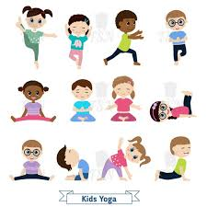 | ENGLISH  Writing Instructions  HANDWRITING  Number Handwriting and words containing Curly Cal, Lens Ladder or Zig Zag Letters  PHONICS  Daily Phonics Sessions  READING  Daily Story Sessions including Helicopter Stories, Tales Toolkit Stories and Talk for Writing & Learning Poems.  Remember to bring in reading books and diaries every day. Please sign the diary when you have heard your child/ren read. | 22.9.25  Our value this week is:  Good Manners  We will be reading  How do dinosaurs eat their food?  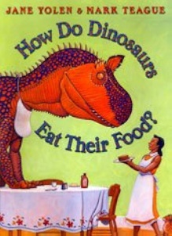 | MATHS  Number  Greater than and less and the same as  < > =  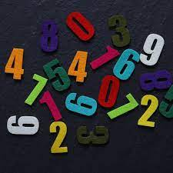 | MUSIC  Songs & rhymes, including Harvest songs  Wendover Music Mini Mozart Performance  Harvest Festival  
COMPUTING

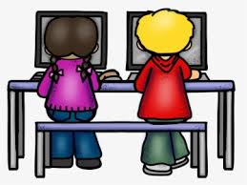

E-safety & Laptops
ART/CRAFT  Mark Making  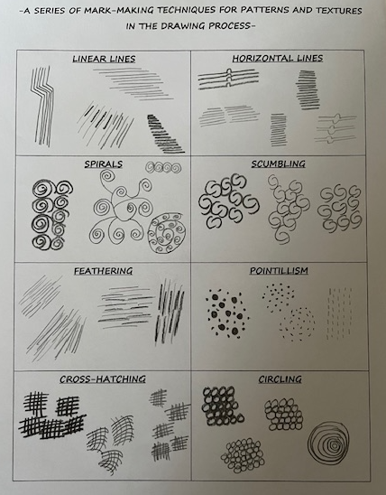 | PSHE    Stories: The Lion & The Mouse & Miss Molly’s School of Manners  Linked to Good Manners  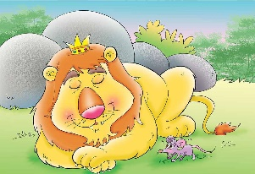 | SCHOOL VALUE ACTIVITIES AT HOME  Perhaps your child/ren could do the following at home to model Good Manners:  Say Please and Thank You to others  Show patience  Wait their turn to talk  Take turns in a game or board game with others  Say kind words to others  Offer something to others before taking for themselves | GEOGRAPHY  Children will continue to learn about UK: England, Scotland, Wales, Ireland.   | FINE & GROSS MOTOR  Funky Fingers:  Cutting Skills  Crossing the mid-line  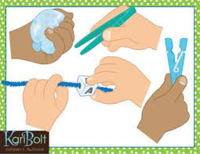
RE
Places of Worship - Judaism
