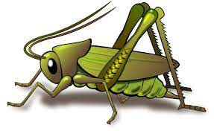
Spring 2 Week 4
Theme of the week – Dinosaurs How do you look after your pet? Who looks after you?
Activities based on the interests of the children….
This week’s story is ‘How to look after your Dinosaur’ by Jason Cockcroft  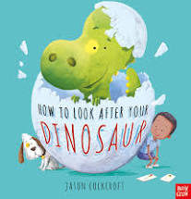  We will be developing our communication and language skills with special words throughout the week. We have been learning key vocabulary from the book and thinking about alternative words for that vocabulary.  Conversation starter - Would you rather have a dinosaur, dragon or a dog as a pet? | Our poem this week is called:  Hungry Birdies  I have built a little nest, look inside, look inside.  Hungry birdies with their beaks, open wide, open wide.  And the little birdies grow, day by day by day.  ‘Till they spread their wings and fly, far away, far away.   | In Maths we will be continuing to focus on comparison of amounts – “is this more than or fewer than?”  We will also be continuing to subitise to 5  “What can you see? How can you see it?”  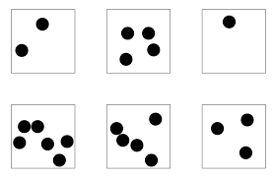  We will be exploring exploring how to separate a group of 4 or 5 objects in different ways, but recognising that the total is still the same.
Our number rhyme this week is 5 Buzzy Bees  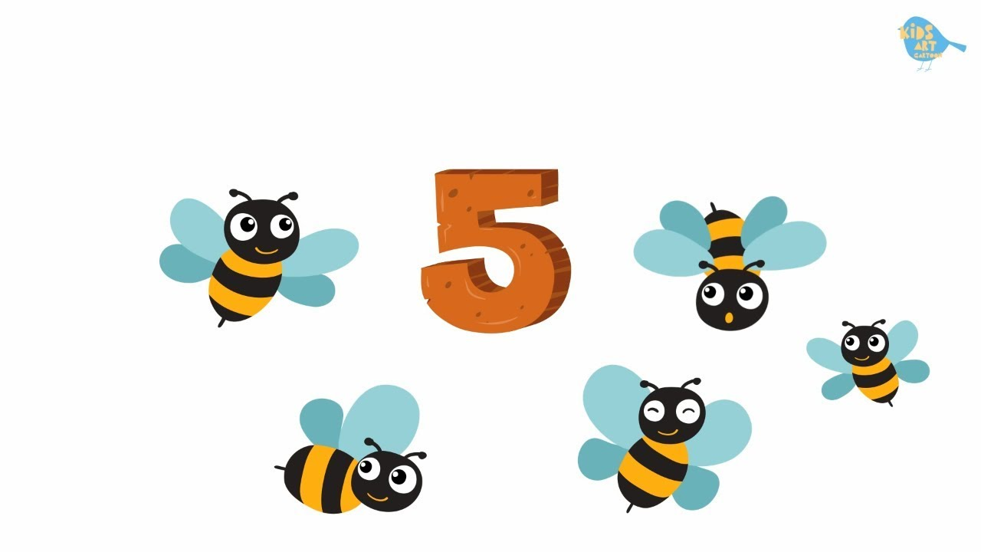 |   This week we will be continuing to develop our ‘Phonological Awareness’ by listening to “robot talk” for a word and then identifying the correct word. E.g. I say C - -a – t. Can you point to that picture?  Ideas for phonic activities at home:  When you are asking your child to do something, break down one of the words. E.g. Can you pull up your z – i - p?  Can you get your c – oa –t ?  Please can you clean your t – ee - th? | There will be more exciting dinosaur themed opportunities this week!  

