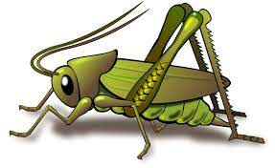
Health Week: How can I keep myself Healthy? Autumn 2 Week 1
Value of the Week: Belonging
Activities based on the interests of the children….
This week it is Health week. We will be learning about the importance of keeping ourselves fit and healthy.  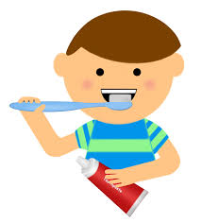  We will have a visit from Dr Evans, who will be talking to us about Going to the Doctors. We will also be reading the story ‘First Experiences, Going to the Doctors’.  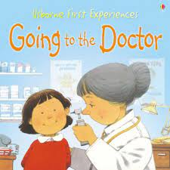  We will be learning about how to keep ourselves healthy through a variety of stories. | We will be listening to stories, rhymes and fairy tales.    We are starting to learn our Christmas Poems and songs ready to show you.   | We will be creating a healthy snack on a plate, in the shape of a face.  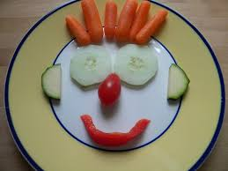  We will have fun making and completing obstacle courses during our outside play and practising our bat and ball skills.  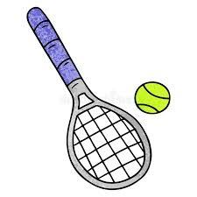  We will be playing outdoor ring games.
This week our Number Rhyme is ‘5 Little Men in a Flying Saucer’  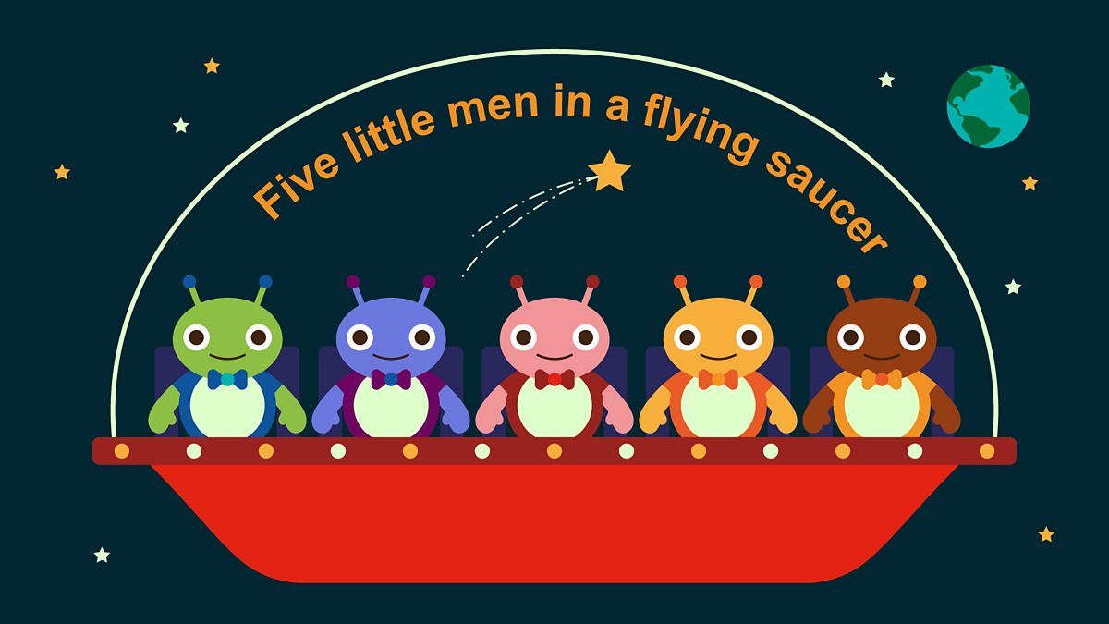  We will continue to subitise groups of objects (0-3). We will practice trying to say how many things we can see without counting. | We will be reading several books including  The Very Hungry Caterpillar by Eric Carle, Wash Your hands by Tony Ross and Hop, Skip and Jump Maisy by Lucy Cousins  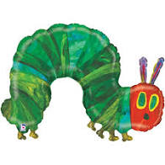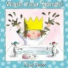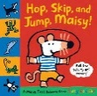  The Nursery Rhyme of the week is ‘Mary had a little lamb.’  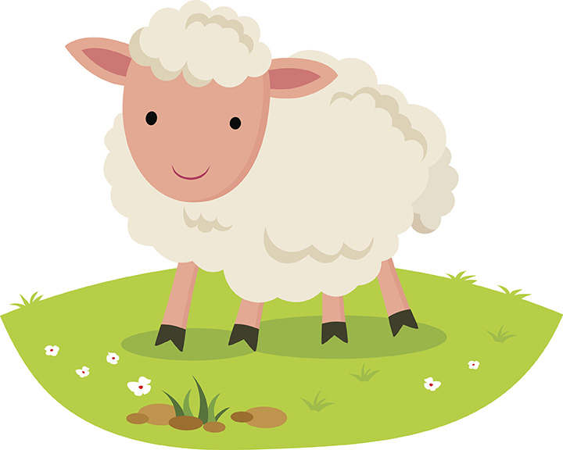 | Listening Len is our supersonic phonic friend. With his help we are learning to be good listeners. In the classroom we have a puppet and we have learnt some new games which your children may tell you about.  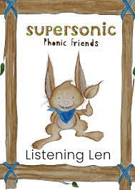  This week we continue with Environmental sounds. We will be identifying, recollecting and talking about different sounds.  Ideas for phonic activities at home:  Find some old socks. Fill them with objects (ie, rice, peas, pebbles shells coins) Let your children identify the objects inside, talking about the sounds that the items make when the socks are shaken.

