What We Are Learning Autumn 1 Week 7
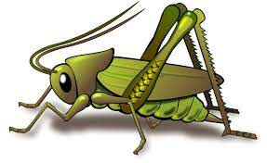
Value of the Week: Reflection
Activities based on the interests of the children….
This week we will be thinking about our school value of Reflection. We will be learning to think deeply or carefully about something and how to improve our work and behaviour. We will be reflecting on our work done so far this term by sharing the children’s learning journals together.    We will be reflecting on all of our behaviour expectations this week: do look after property, do work hard, to be kind and helpful, do be polite and do listen.  WOW! We have learnt so much in our first half term in Crickets. | We will be listening to stories, rhymes and fairy tales.  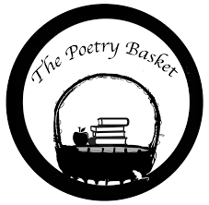  This week we will be revisiting and reciting the three poems learn this half term. They are called Chop Chop, Wise Old Owl and Falling Apples.  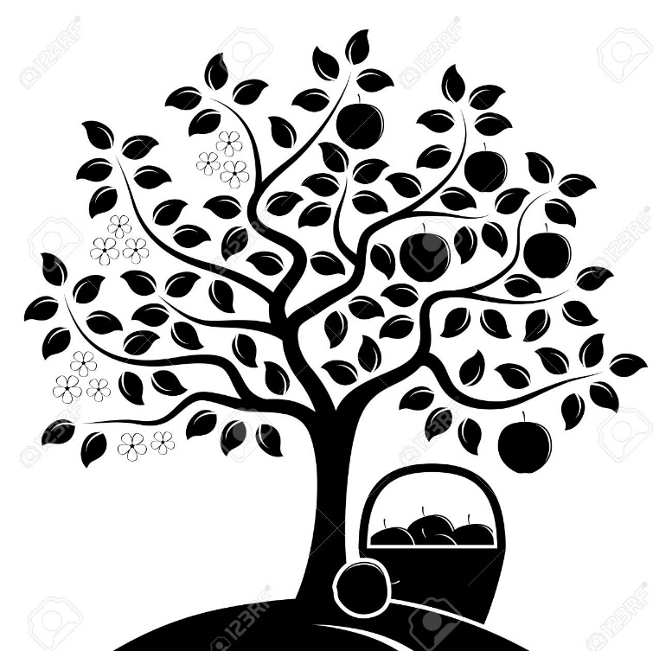  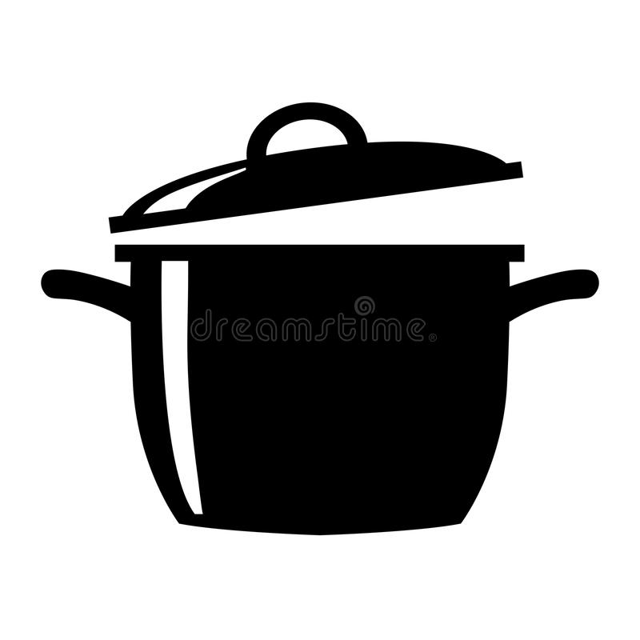  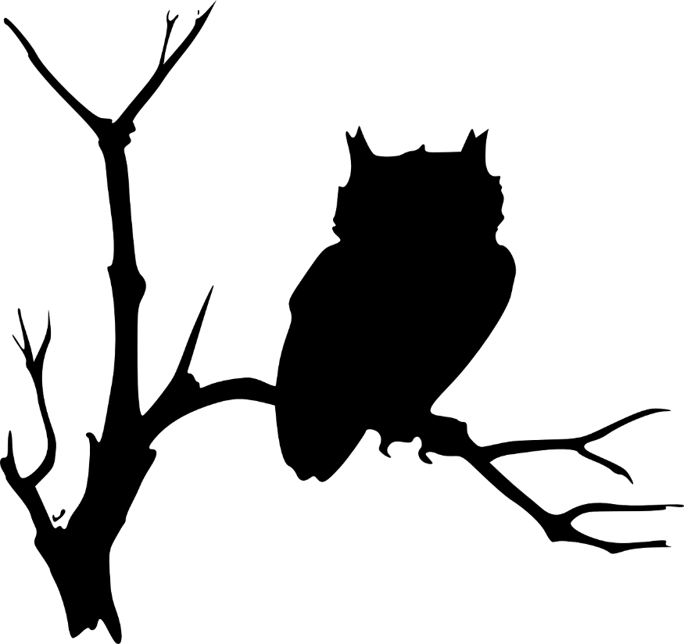  Crickets are doing so well learning these poems.  Ask your child to recite one and show you the actions. | This week our core text is ‘We’re Going on a Bear Hunt’ by Michael Rosen  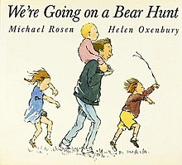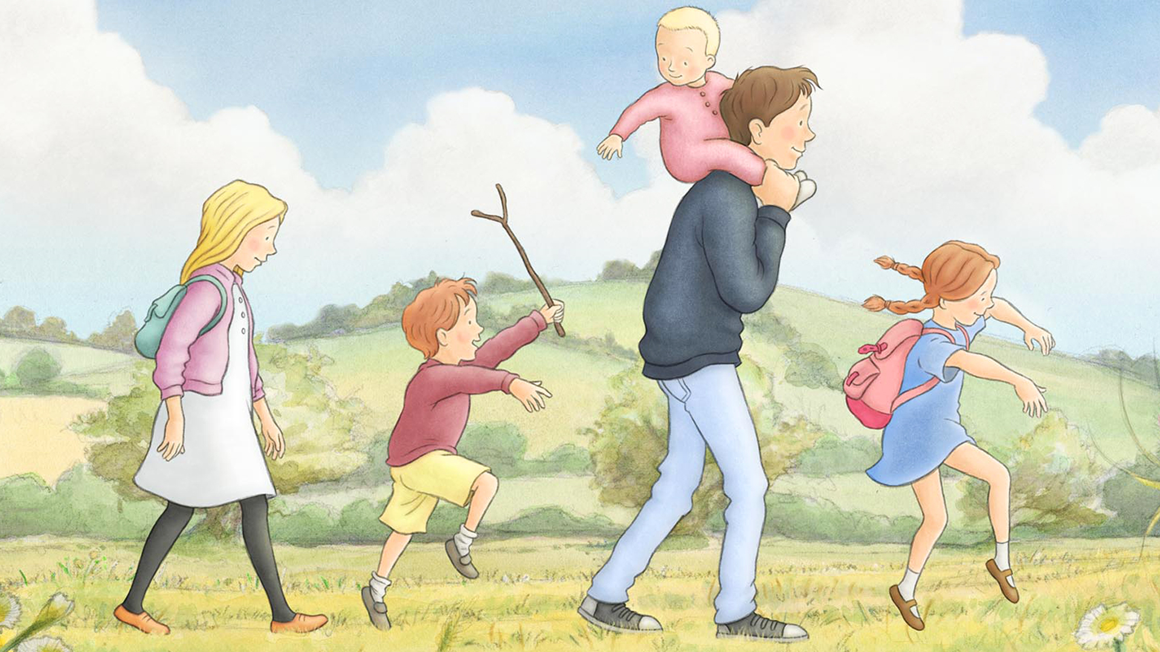  We will also continue to read familiar stories from our classroom.  We will be singing the Nursery Rhyme ‘Sleeping Bunnies’  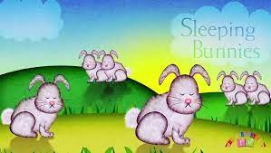
This week our Number Rhyme is ‘5 Green Bottles’  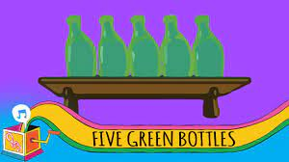  We will continue to subitise groups of objects (0-3). We will practice trying to say how many things we can see without counting.  “What do you see? How do you see it?” We will be encouraging the children to represent their Maths by mark making.  Please continue to support us at home by practising show me fingers (to 3) and counting forwards (to 5). | We will be learning how to make models out of boxes and other recycled containers.  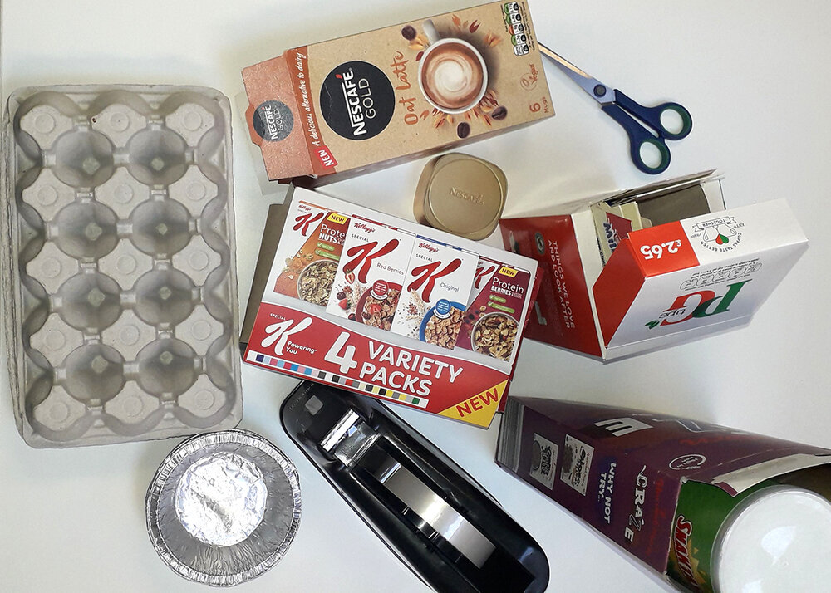  We would really appreciate you sending in any clean recycled items for the Crickets to use. | We are continuing to develop our gross motor skills with our ‘Squiggle while you Wiggle’ dance. We will be practising our mark making whilst we play by writing recipes, making shopping lists or writing telephone messages and postcards.  We will also be continuing to make different marks outside using large up/down movements whilst using the water brushes, chalks sand, and in the air with noodles and scarves.  We will be practising the pre writing pattern I and ---- .  We have noticed the leaves falling in our outside area and are developing gross motor skills with the constant sweeping.

