Question of the Week: How many plants and flowers grow in the Foundation Stage garden? WB: 06.05.24
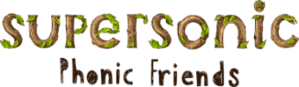  In Phonics we will be focusing on learning how to write words using the following spellings for the sounds  ur ow oi er  We will also be practising the following tricky words and high frequency words  they my by are see | In Handwriting,  we will be continuing to practise writing our zig zag letters x and y.  We will be recognising which letter family the letters come from and saying the ditties as we practice! | In Writing,  we will be learning how to write instructions using the time connectives  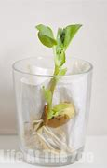  First,  Then,  Next,  After that,  Finally  We will be writing instructions for how to plant a seed. | Maths  In Maths, we will be comparing quantities to 10 using a range of natural materials such as beans and seeds. We will focus on key vocabulary such as less, more and same.  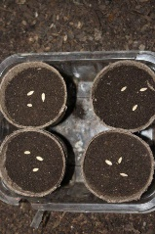
A Little Seed  A little seed for me to sow,  A little soil for it to grow.  A little hole, a little pat,  A little wish, and that is that.  A little sun, a little shower,  A little wait, and then a flower. | Our topic is Nature Detectives – Growing  We will be reading The Tiny Seed, Jasper’s Beanstalk and The Enormous Turnip.  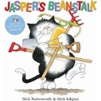  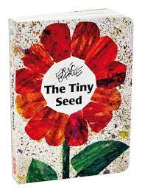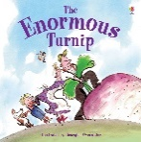  This week the children will be thinking about the lifecycle of a variety of plants. They will continue to identify and classify plants within our learning environment.  The children will revisit their previous learning and consider how the flower bulbs that they planted in the Autumn term have changed over time.  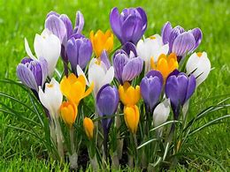  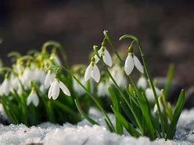  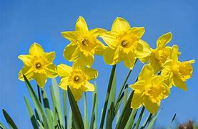 |  | Parents Notices  Reminder  BANK HOLIDAY  MONDAY 6TH MAY 2024  Coats & Sunhats  Please ensure children have a waterproof coat and a sunhat everyday. Please apply sun lotion if needed - dependent on the forecast.  We are outside regardless of the weather.

