WB: 10.10.23
Value: Independence Expectation: Do be honest Question of the Week: What can we use our nose and sense of smell for?

We will be reading the story Only One You  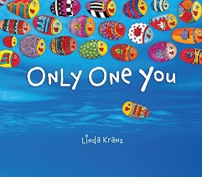 | This week we will be exploring our sense of smell. We will be thinking about which senses are stronger than others and how our sense of smell can help keep us safe.  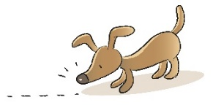 | In our ‘Investigation Area’ we will be blind smelling different scents and identifying familiar fragrances. Picture prompts will be provided to support us with our predictions.    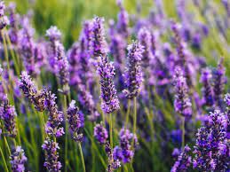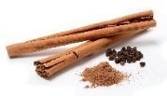 | In ‘Squiggly Whilst We Wiggle’ we are practsing the following patterns:  / \ X  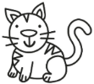
Poetry Basket Poem;  A Cup Of Tea  Here’s a cup,  And here’s a cup,  And there's a pot of tea,  Pour a cup,  And pour a cup,    And have a drink with me  -----------------------------------------------------------------------  Home Learning Tips and Hint  Daily reading with your child will help them to establish a love of reading and enable them to develop their comprehension skills.  Grandma’s Fantastic Words  proud/ ashamed  pleased (proud delighted)  sorry (ashamed) | Our value this week is -  Independence    To be able to achieve or do something without the help and support of others.  The children will demonstrate in a variety of ways different levels of independence from simple acts of putting on their coats, writing their names and learning new skills.  Our behaviour expectation this week is  Do be honest |  | In Maths we are continuing to Subitise and have been recognising dice patterns without counting the dots. Play a board game at home with your child and encourage them to recognise the amount rather than count them.    We have also been looking at making patterns. Can your child make a repeating pattern?
In Phonics we are continuing to segment and blend words. A game to play could be Phonics Play, Phase 2, set 1 https://www.phonicsplay.co.uk/resources/phase/2/buried-treasure

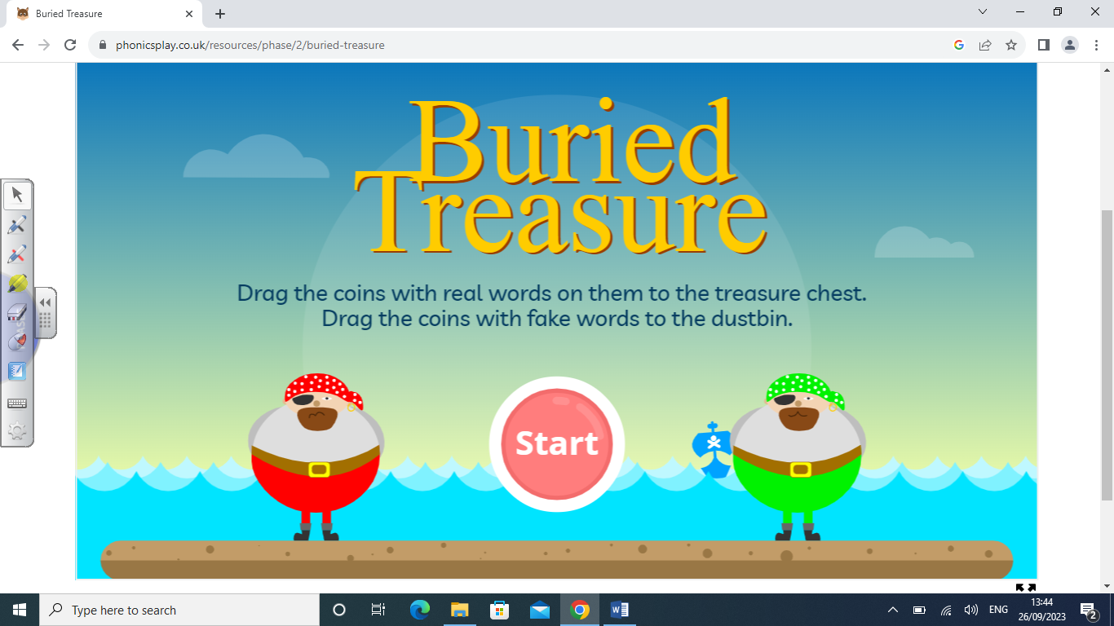

In Supersonic Phonics we are going to be revisiting previous sounds and
tricky words learnt so far – I, is, to, the, go, no,

