PE  May Pole Dance Prep  Mindful minutes  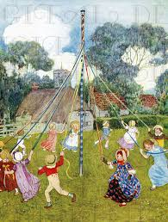 | ENGLISH  Children will be looking at Instructions.  We shall use the book  How to Wash a Woolly Mammoth as inspiration.  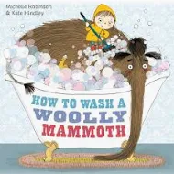  SPAG / HFW / TW / CEW. Reading comprehension  HANDWRITING  Joining patterns  PHONICS  Daily Phonics Sessions.  READING  Daily Story Sessions & Learn a Poem.  Remember to bring in reading books and diaries every day. Please sign the diary when you have heard your child/ren read.  Guided Reading: Comprehension Strategies. | 13.4.26  We will continue to focus on our school Behaviour Expectations & Values.  We will be reading:  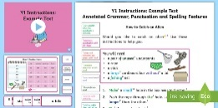  Instruction Texts & Reading Comprehensions | MATHS  Children will be looking at Division.  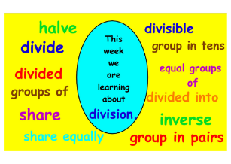 | MUSIC  A focus on singing expressively, playing tuned musical instruments, creative composing, responding to pitch changes and playing, creating and performing rhythmic patterns.  The children will also learn the May Day songs ‘Good Morning Ladies & Gentlemen’ and ‘Hey Ho! It’s our May Day Song!’  
ART – GEOGRAPHY  The children will create Birds eye view plans of the school & the local area (using an aerial shot) and they will learn about scale and perspective.  COMPUTING  The children will learn all about Spreadsheets. |  |  | SCIENCE  The children will be learning about Plants. They will plant beans.  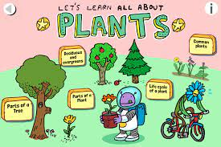  RE  The children will be learning about Abraham and how he is an important person n the Jewish faith.  
PSHE  Behaviour Expectations & Values  Reflection  Circle Time  Family   |  | Homework    New homework will be issued on 16/4/26 based on their learning in Science. It needs to be returned on 28.4.26 | FINE & GROSS MOTOR  Funky Fingers  Crossing the mid-line.  Further developing of cutting skills.  

