PE  May Pole Dance Prep  Mindful minutes  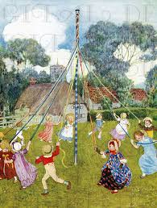 | ENGLISH  Children will be looking at Instructions.  We shall use the book  How to Wash a Woolly Mammoth as inspiration.  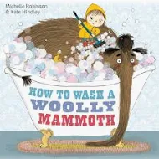  SPAG / HFW / TW / CEW. Reading comprehension  HANDWRITING  Joining patterns  PHONICS  Daily Phonics Sessions.  READING  Daily Story Sessions & Learn a Poem.  Remember to bring in reading books and diaries every day. Please sign the diary when you have heard your child/ren read.  Guided Reading: Comprehension Strategies. | 20.4.26  We will continue to focus on our school Behaviour Expectations & Values.  We will be reading:  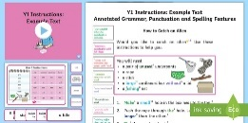  Instruction Texts & Reading Comprehensions | MATHS  Children will be looking at Division and Fractions.  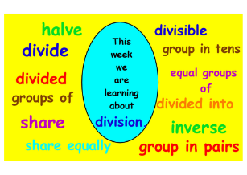 | MUSIC  A focus on singing expressively, playing tuned musical instruments, creative composing, responding to pitch changes and playing, creating and performing rhythmic patterns.  The children will also learn the May Day songs ‘Good Morning Ladies & Gentlemen’ and ‘Hey Ho! It’s our May Day Song!’  
ART – GEOGRAPHY  Children will make clocks to support their learning of time later in the term  COMPUTING  The children will learn all about Spreadsheets. |  |  | SCIENCE  The children will be learning about Plants. They will observe the beans and thinking about germination.  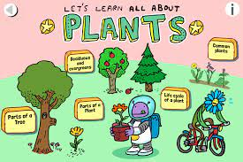  RE  We will be looking at the story of Moses.  
PSHE  Behaviour Expectations & Values  Reflection  Circle Time  Family   |  | Homework    New homework was issued on 16/4/26 based on their learning in Science. It needs to be returned on 28.4.26 | FINE & GROSS MOTOR  Funky Fingers  Crossing the mid-line.  Further developing of cutting skills.  

