
What We Are Learning Autumn 1 Week 5
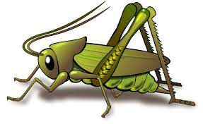
Value of the Week: Good Manners.

Activities based on the interests of the children….
We are learning about the JHSW Values and Behaviour Expectations. We have already thought about being the best that we can be, belonging and perseverance and collaboration.  This week we will be thinking about Good Manners – We will be learning concept of being polite in the way that we speak to others saying please, thank you, excuse me.  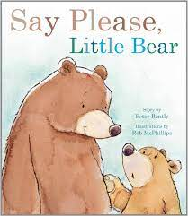  Our behaviour expectation for this week is Do be polite and do be gentle.  We will also be continuing to learn about how to look after our classroom and each other, to work hard and to be kind and helpful.  Kindness cups will be awarded to those children who are spotted being kind and helpful to one another. | We will be listening to stories, rhymes and fairy tales.  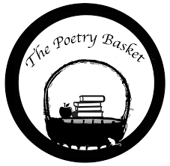  We will also be learning our second poem from Poetry Basket. This is a special rhyme and movement activity we do during our morning sessions. It is great fun and features a range of seasonal and classic poems. See if your child can recite our first poem to you. It is called Chop Chop.  Wise Old Owl  A wise old owl sat in an oak,  The more he heard, the less he spoke.  The less he spoke, the more he heard.  Why aren’t we all like that wise old bird?  We would love you to share these poems with your child each week. | Continuing out This is Me topic and sense of belonging, this week we will be having conversations about our families. We will make talking about who is important to us and who lives in our house.  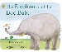  We will continue to teach children how to self-regulate and understand their feelings.  This week our core text is The Elephant and the Bad Baby by Elifrida Vivpont.  We will also be reading familiar stories from our classroom.
This week our Number Rhyme is 10 in the Bed  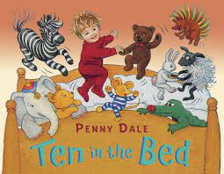  We will be subitising groups of objects (0-3). We will practice trying to say how many things we can see without counting.   | We will be playing ‘Bananas for Dinner’ which is a listening game and in circle time playing other Communication and language games.  Communication and Language websites have a wealth of information and ideas.  https://hungrylittleminds.campaign.gov.uk/  https://www.bbc.co.uk/tiny-happy-people  https://wordsforlife.org.uk/activities/filter/?age=3-4  https://ican.org.uk/i-cans-talking-point/parents/  Please don’t hesitate to ask for more information.  We will be singing the Nursery Rhyme “Twinkle Twinkle Little Star”  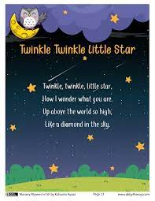 | We are developing our gross motor skills with our ‘Squiggle while you Wiggle’ dance. We will be practising our mark making whilst we play by writing recipes, making shopping lists or writing telephone messages.  We will also be continuing to make different marks outside using large up/down movements whilst using the water brushes, chalks sand, and in the air with noodles and scarves.  We will be practising the pre writing pattern I.

