WB: 10.11.25 | Value: Perseverance | Behaviour Expectation: Do work hard
Question of the Week: What can I do to keep myself healthy?

We will be reading the story:  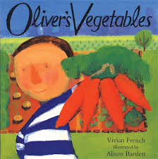  By Vivian French  Oliver’s Vegetables | Grandma’s Fantastic    well healthy  sick/ ill/ not heathy unwell/ poorly | Poetry Basket  Poem  Sliced Bread  Slice, slice, the bread looks nice,  Spread, spread, butter on the bread,  On the top put jam so sweet,  Now it’s good enough to eat.  Yum, Yum, Yum,Yum  Wipe! | Tales Toolkit  We will be continuing to create class Tales Toolkit using symbols. Can you make up a story at home. Remember to use the sentence starters
   | One upon a time/ A long time ago there was a ……. who lived in …………  One day……  But…..  So…..  Snip snap snover, the story is over. Snip snap snout the story is out/ Tap the nail the nail bends, this is how the story ends.
  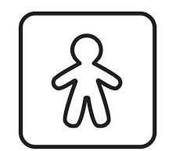
  
  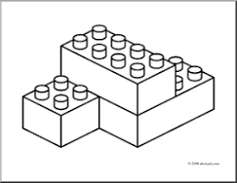
  
  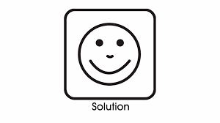
Curious Conversations:
When you got hungry, what would you eat? (You Choose)
When you get tired and feel like a snooze, where would you sleep? (You Choose)
Phonics  We will be learning to write the spellings for the sounds:  i n m d  .  We will be learning to write the tricky words I and is and the high frequency words in it an dad and. Please see Home Learning for further details. | Our value this week is -  Perseverance    To keep on putting in effort to achieve something, even if is challenging  The children will demonstrate in a variety of ways different levels of perseverance throughout their learning this week including:  Writing our new sounds and Tricky and High Frequency Words .

To answer the questions of the week How can I keep myself healthy we will have a visit from a dentist. We will learn about healthy food and unhealthy food, the importance of staying hydrated and exercising. We will also be learning sings about keeping healthy.  .  We will be continuing our ‘Growth Mindset Journey’ by revisiting some of the different ways to look after and grow our brain:  - Exercising our brains (puzzles and problem solving)  - Looking after our brains (sleeping, eating healthily and drinking water)  - Challenging ourselves  - Being positive ( I can…I can’t do it yet.”)  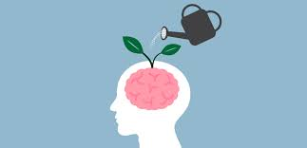 | .  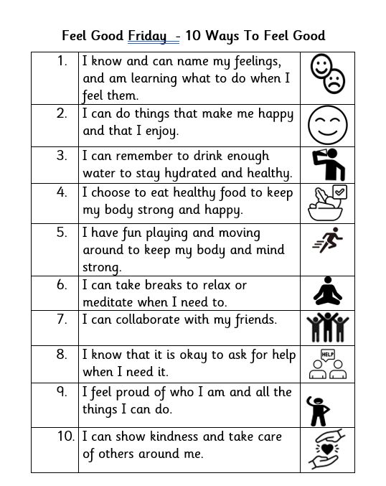 | We will be experimenting with different ways to represent fruit and vegetables using the skills we have learned so far, including mark making, painting, printing and drawing.  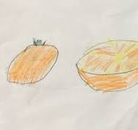  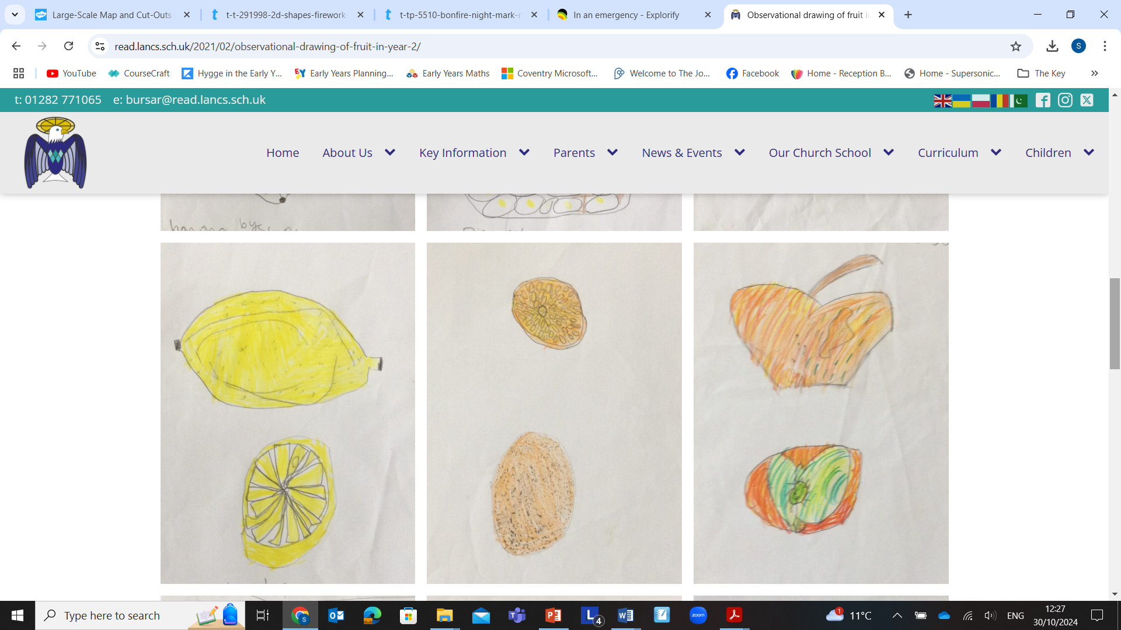
Please share Library Book Club


