WB: 19.1.26 | Value: Collaboration | Behaviour Expectation: Good Manners
Questions of the Week: What happened to the dinosaurs?

We will be reading the story:  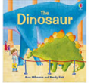 | Grandma’s Fantastic    happily luckily fortunately  unhappily unluckily unfortunately | Poetry Basket Poem  Triceratops  I’m Triceratops I’m pleased to say,  I can make all my enemies run away,  I’ve got 3 horns upon my head,  But they’re not very comfortable when lying in my bed! | Tales Toolkit  We will be continuing to create class Tales Toolkit using symbols. We will be substituting But for Unfortunately and So for Fortunately Can you make up a story at home? Remember to use the sentence starters
   | One upon a time/ A long time ago there was a ……. who lived in …………  One day……  Unfortunately …..  Fortunately …..  Snip snap snover, the story is over. Snip snap snout the story is out/ Tap the nail the nail bends, this is how the story ends.
  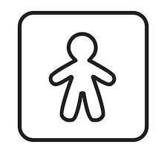
  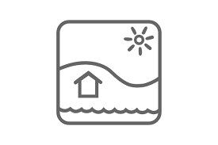
  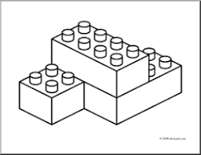
  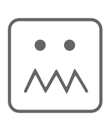
  
Curious Conversations:
Would it be a good thing or a bad thing if dinosaurs roamed the land?
Would you rather be a TRex or a mouse? Why?
Phonics  We will be learning to write the spellings for the sounds:  ch sh th ng  .  We will be learning to write the tricky words they, my, by and the high frequency word that, this, then, them, with. Please see Home Learning for further detail | Our value this week is -  Collaborate    To work with someone else, or a group, to achieve or do something  The children will demonstrate in a variety of ways different levels of collaboration throughout their learning this week.  Our behaviour expectation this week is: Do be kind and helpful.

To answer the questions of the week What happened to the dinosaurs? We will be observing how a large block of ice changes over time.  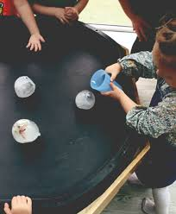 | We will be revisiting different ways to join:  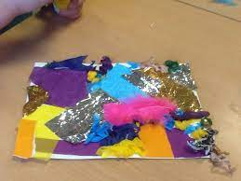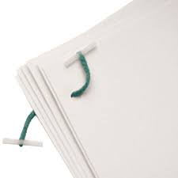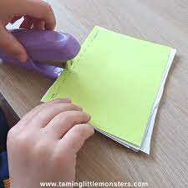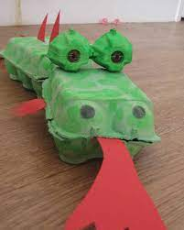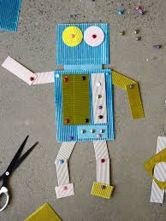 | Maths  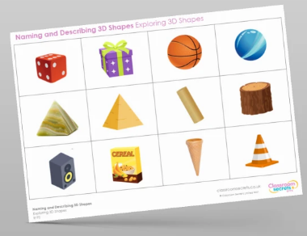  We will be learning about the properties of Solid (3D) shapes.
  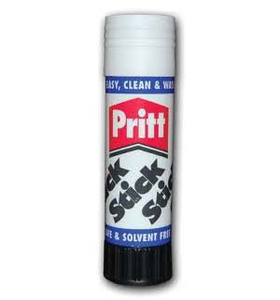 | 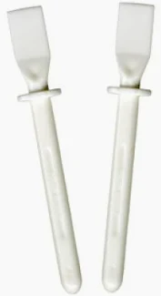 | 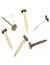 | 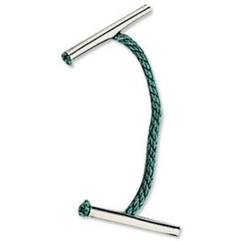 | 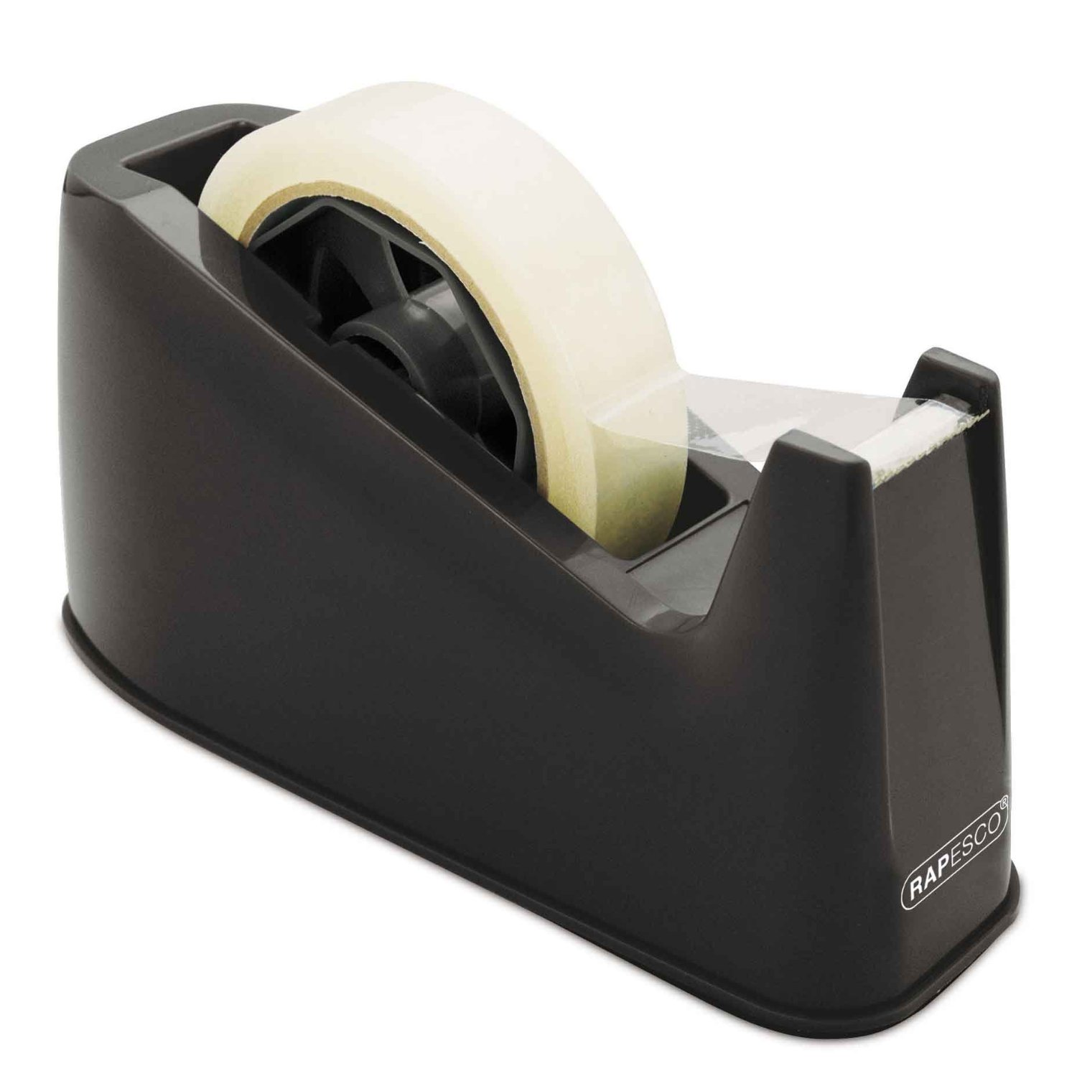 | 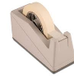 | 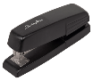 | 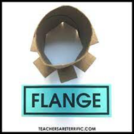
  Glue stick | PVA glue | Split pins | Treasury tags | Cello tape | masking tape | stapler | flange
I Am a Palaeontologist  https://www.youtube.com/watch?v=B7zo2zY1Zqg | Please share Library Book Club  