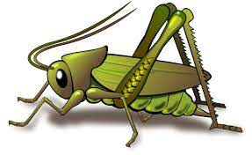
Value of the Week: Collaboration Autumn 2 Week 4
Activities based on the interests of the children….
This week we will be thinking about our school value of Collaboration. We will be continuing to learn to work together as a group or with someone else to achieve or do something.    Our behaviour expectation for this week is Do be kind and helpful. We will be awarding kindness cups to children who are spotted showing kindness to others. | We will be listening to stories, rhymes and fairy tales.    We are continuing to learn our Christmas Poems and songs ready to show you.   | This week we continue to read our core text is ‘Dear Zoo’ by Rod Campbell and linked texts.  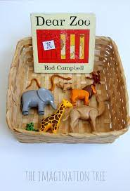  To help develop your child’s Communication and Language skills choose different animals that could be in the zoo and ask them to provide their own ideas.  “They sent me a Penguin but it was too slippery.”  We will also continue to read familiar stories from our classroom.
This week our Number Rhyme is ‘5 Buzzing Bees’    We will continue to subitise groups of objects (0-3). We will practice trying to say how many things we can see without counting.   | The Nursery Rhyme of the week is ‘Hey Diddle Diddle, the cat and the fiddle,’  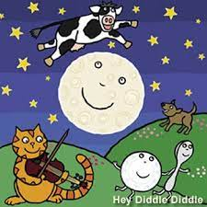  Our Creative focus this week is Model Making in relation to animals and Dear Zoo.  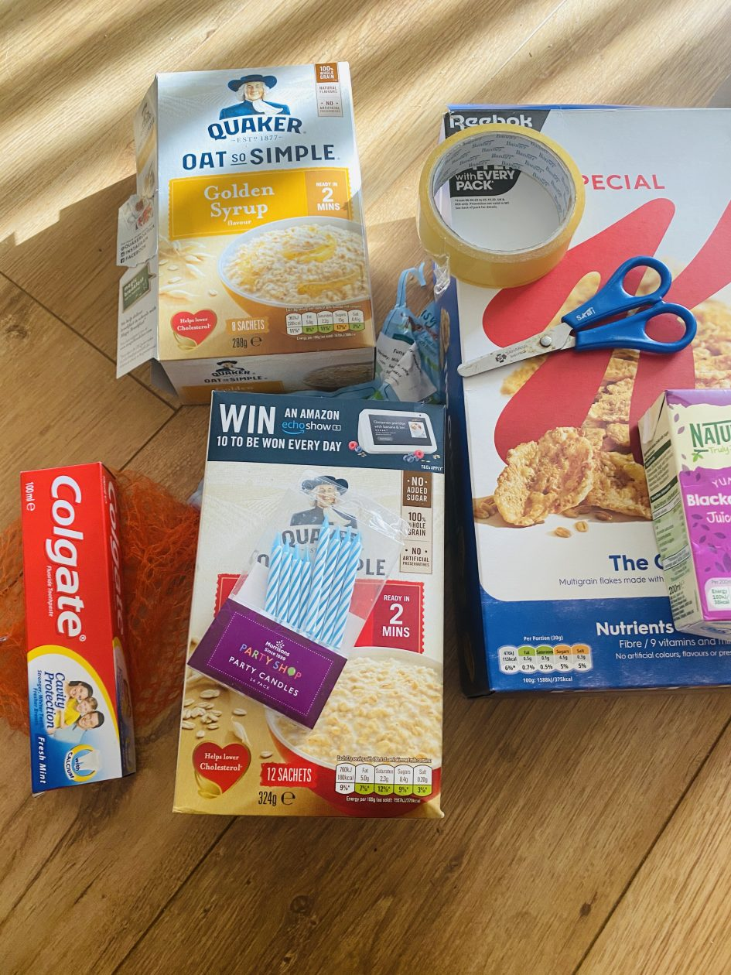  Your recycled boxes and containers would be very welcome. | Listening Len is our supersonic phonic friend. With his help we are learning to be good listeners. In the classroom we have a puppet and we have learnt some new games which your children may tell you about.  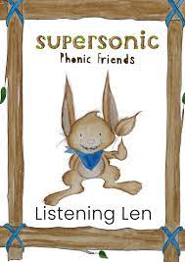  This week we be exploring Instrumental sounds. We will be identifying instruments and distinguishing between sounds and recognise and respond to sounds they hear.  Ideas for phonic activities at home:  Can you make a simple musical instrument and bring it into school to show us? Maybe a shaker or something else that makes a sound. Talk about the sound that it makes.

