Question of the Week: How many creatures find their homes in the Foundation Stage garden? WB: 15.4.24
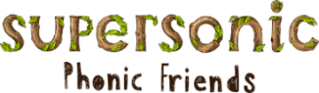  In Phonics we will be revisiting the Basic 3 spellings for the sounds  ch sh th ng  Tricky Tess Words  he she we me be  Read with Rex Words  will and that | In Handwriting, we will be continuing to practise writing our Curly Cal letters.  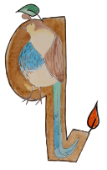  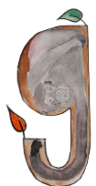  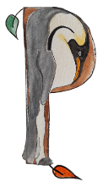  We will be recognising which letter family the letters come from and saying the ditties as we practice! | In Writing, we will be writing sentences that include the spellings for the sounds, high frequency words and tricky words that we are revising. | Maths  In Maths the children will continue to engage with activities that draw attention to the purpose of counting – to find out ‘how many’ objects there are.  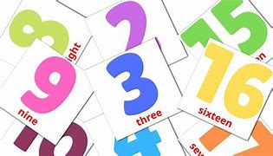  The children will also revisit the concept of cardinality – the idea that the last number in the count tells us how many things there are altogether.
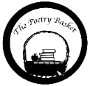  Under a Stone  Under a stone where the earth was firm,  I found a wiggly, wriggly worm.  “Good morning,” I said.  “How are you today?”  But the wiggly worm just wriggled away. | Our topic is ‘Nature Detectives’ – Mini Beasts  We will be reading –  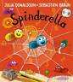  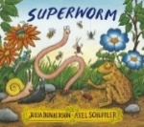  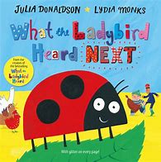  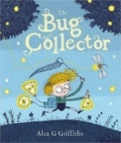  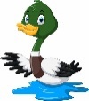  We will be looking at nature in the environment. In particular, wild life on the canal and mini beasts in the garden. We will visit our bug hotel. |  | Parents Hints and Tips  Coats & Sunhats  Please ensure children have a waterproof coat and a sunhat everyday We are outside regardless of the weather.  Junk Modelling  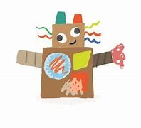  If you have any recycling at home, for example - cereal boxes, toothpaste boxes and kitchen roll tubes, we would be grateful to receive any donations for our junk modelling area.

