English  This week we are writing instructions using the vocabulary- First, then, next, after that and finally. | Maths  We will be looking at comparing numbers, counting objects and working out which has more or less than. We will then be introducing the more and less symbols. | PE  Our focus in PE in this half term will be multi-skills Please ensure your child has a full, named PE kit including joggers.
Music  We will be rehearsing our Harvest Festival Songs. We will be thinking about using our voices to create an effect. | Week beginning 22.09.25  Incredible Me!  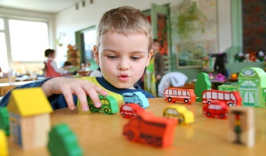 | Science  Animals and Humans  We will be observing, investigating and comparing the human body. We will be working on our questioning skills, identifying what makes a good question.
Poetry  We will be looking at classic Poems from our “Poetry Basket”.  This half term our poems are “All About Me” |  | Art  This half term we are going to be looking at sketching and mark making in Art and using H and B pencils to create different effects.
 | PSHE  This half term we are focusing on looking at our school values and what they mean. This week we are going to be looking at good manners. | Geography  Next week we will be reading ‘Martha Maps it Out’ and thinking about our local geography and where we live.
Phonics
We will be recapping and reviewing Basics 4 and reading CVCC words.

