
Summer 1 Week 5
Question of the Week: What are you afraid of?
Activities based on the interests of the children….
This week’s Story is Nothing Can Frighten a Bear by Elizabeth Dale  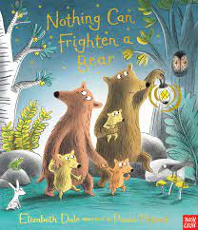  This is a book written in rhyme and tells the story of a bear family going out at night to look for monsters. Daddy Bear knows they don't exist but wants to prove it to Baby Bear.  We will be taking about what makes us feel frightened and what it feels like to be brave.  We will also be reading other bear stories including Goldilocks and the Three Bears and We’re Going on a Bear Hunt. | Poetry basket    Our Poetry Basket Poem this week is;  A Little Shell  Once I saw a little shell,  Upon a garden wall,  I tapped upon a little door,  No answer came at all,  But as I turned to go away,  A snail crept out to see,    Who tapped upon his little door, | Our Rhymes  Our Number rhyme this week is 10 in the Bed  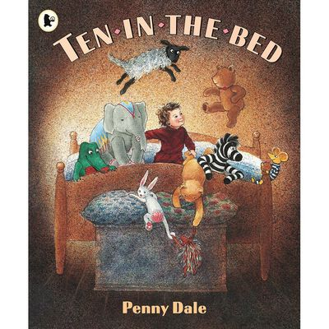  This week we will be playing some of our favourite games including ‘Baers ike honey’ and singing the Nursery Rhyme ‘Teddy Bear, Teddy bear’ with actions.
Maths  We will be continuining to secure our number sense by subitising numbers to 5, reciting and reordering numbers 0-10, finishing the 5 on the five frame and developing our knowledge of part/whole.    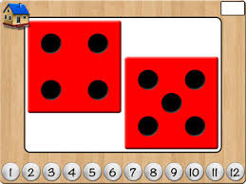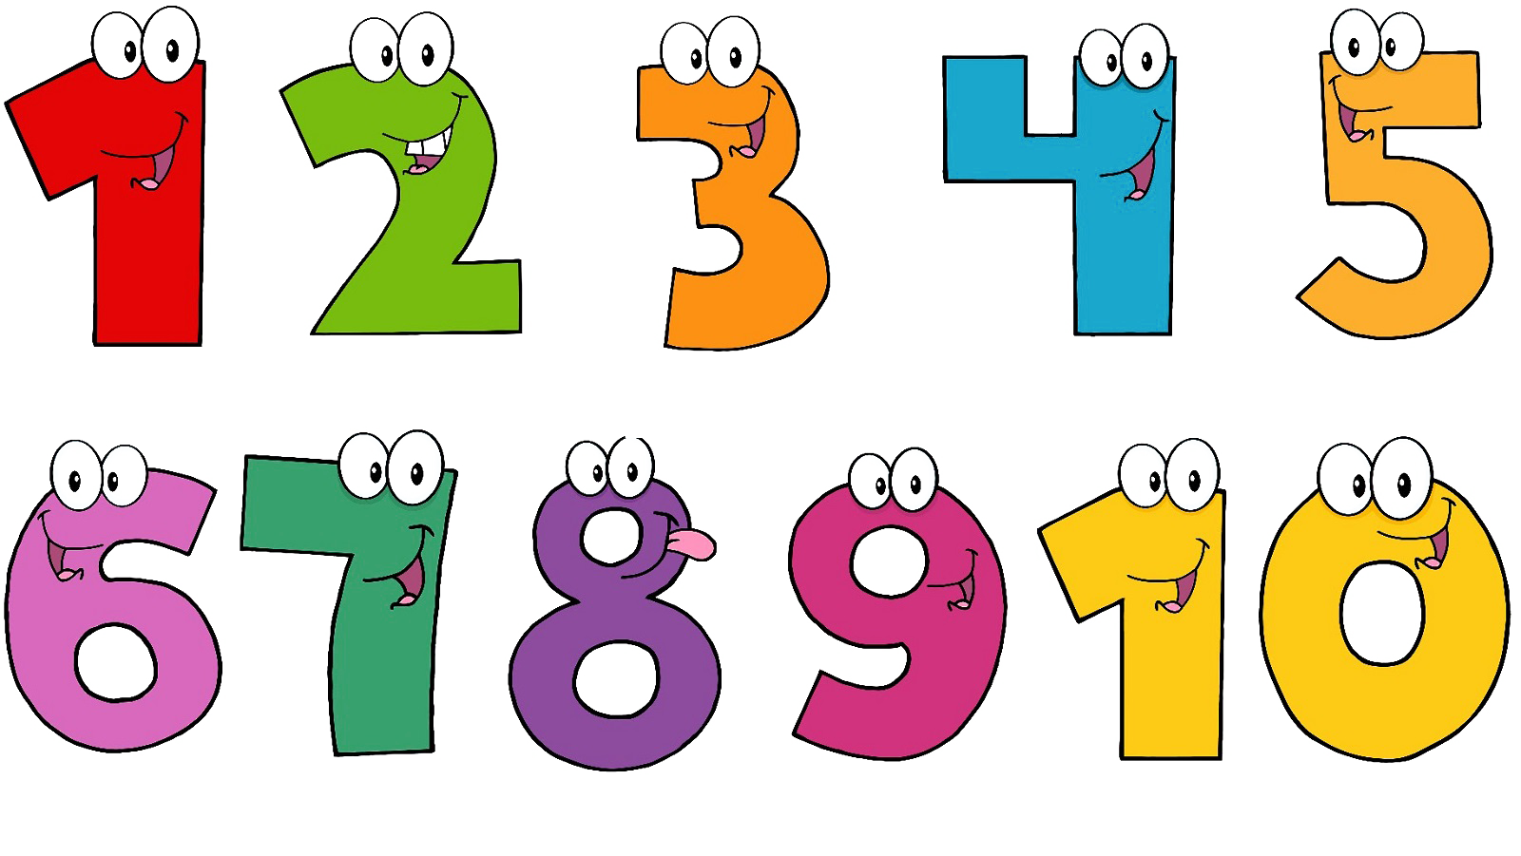 | Expressive arts and design  We will be going on a Bear Hunt exploring movements including crawling, rolling, jumping, skipping and hopping.    We will be exploring materials and being imaginative, making props for story telling. | Phonics  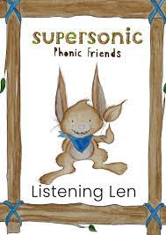  We will be embedding our phonological knowledge learnt so far. We will be doing lots of oral blending and playing fun phonics games.  