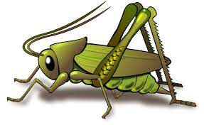
Spring 1 Week 3
Question of the Week: What would you pack in your suitcase?
Activities based on the interests of the children….
This week’s NELI story is ‘Pip and Posy’, The Bedtime Frog by Axel Scheffler  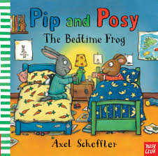  Posy forgot to take her special bedtime frog to Posy’s house. We will be talking about things that are special to us and things that make us feel happy and safe.  We will also be thinking about things we need to pack in our suitcase when we are going on holiday, thinking about differences between winter and summer clothes.  We will learn new vocabulary each day. We would love to hear if your child tells you about the new words that they have learnt. |   Our Poetry Basket Poem this week is;  Pancakes  Mix a pancake,  Stir a pancake,  Pop it in the pan,  Fry a pancake,  Toss a pancake,  Catch it if you can.  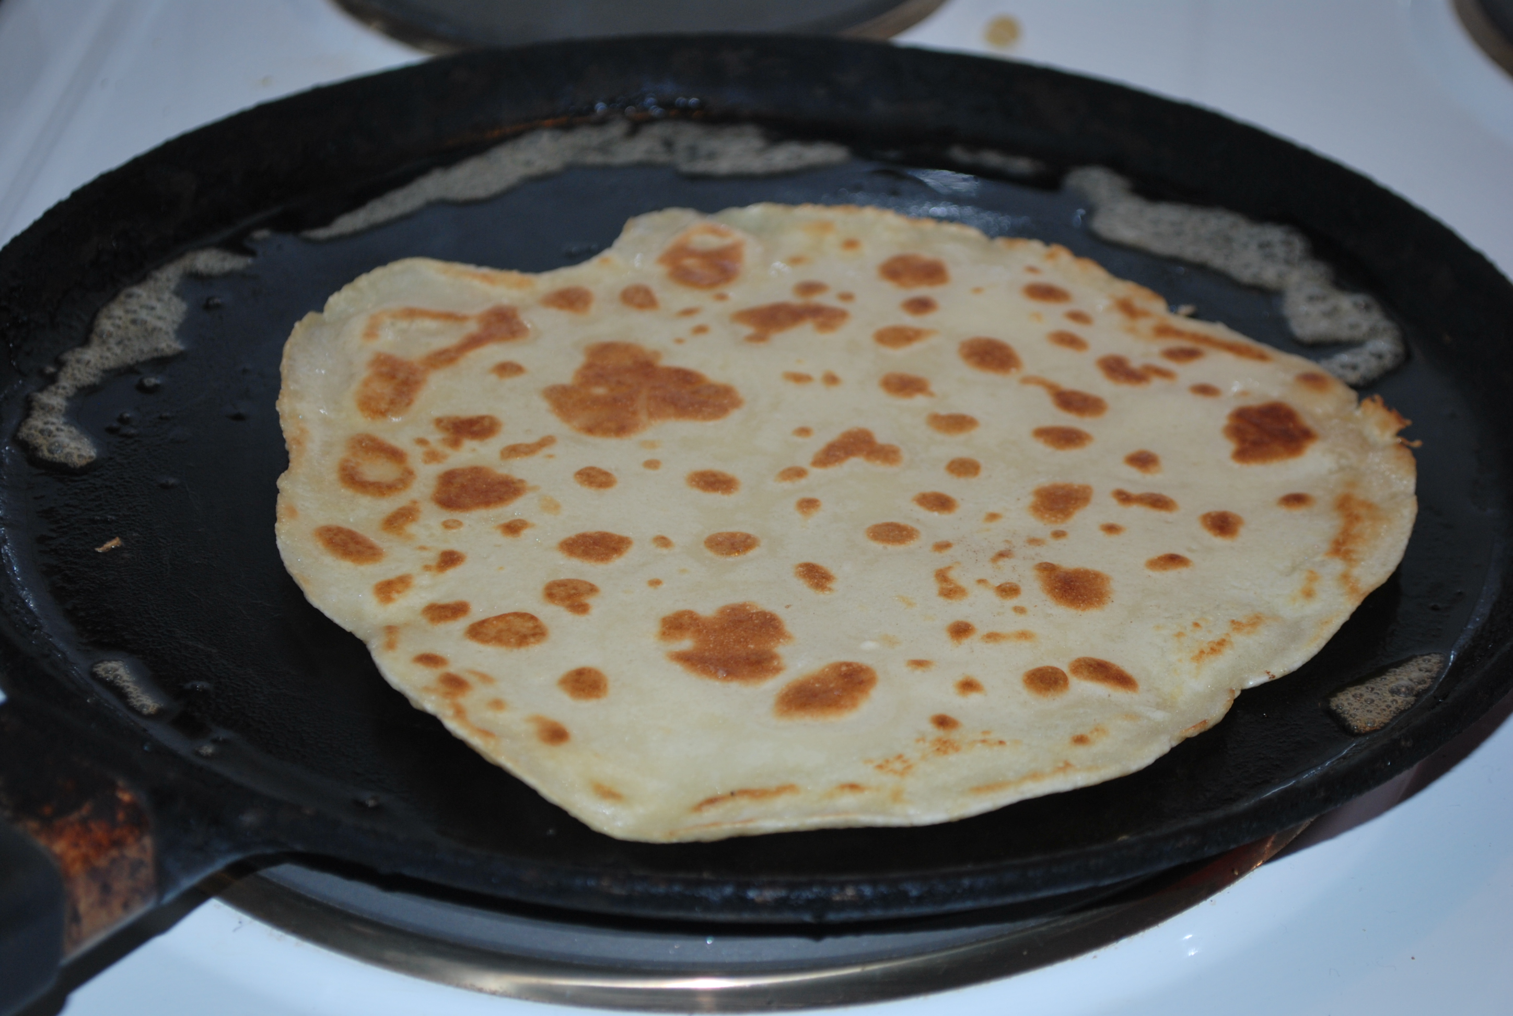 | Conversation Starters – ‘Would you rather pack an alien or a grumpy fairy in your suitcase?’  We will be singing the Nursery Rhyme ‘Row Row Your Boat’    We have had lots of opportunities to float boats in the puddles, make waves and observe ripples.  This week our Number Rhyme is  5 Speckled Frogs  
In number we will be separating a group of 2 or 3 objects in different ways recognising that totals are the same.  | We will be extending our circling mark making and colour mixing skills and applying them to watercolour painting.  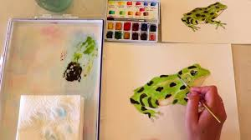 | 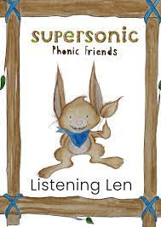  This week we will be beginning to develop understanding of Alliteration . Alliteration is when several words begin with the same initial sound. For example phone, fish, flower, frog,  Ideas for phonic activities at home:  Select a number of objects from around the house that all begin with the same initial sound. Play hide and seek with the objects and then say, for example, “I have found a cap, coat, key and cup. The children need to hear and isolate the initial phoneme (sound) from the rest of the word. Repeat with other objects/phonemes. Ask your child what sound logs they have already learnt and perhaps you could start with those.  t t t terrific tiger - train, tea, tooth, table ,

