Summer 2 Week 5
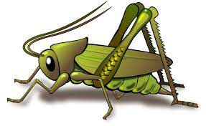
Question of the Week: How have you changed?
Activities based on the interests of the children….
Our story  This week we will be reading ‘When a dragon goes to school’, by Rosalind Beardshaw, in preperation for transitioning up to our new Foundation Stage classes.  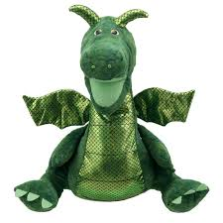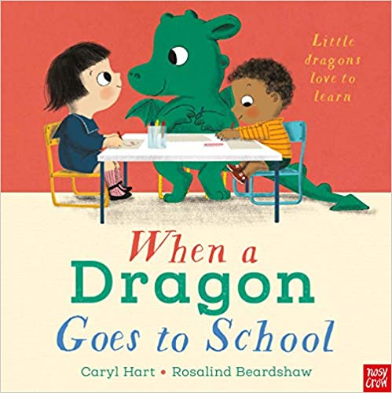  We will be thinking about how we have grown both physically and in our learning as we near the end of our Crickets learning journey. | Poetry basket    Our Poetry Basket Poem this week is;  If I were so very small  If I were so very small,  I’d walk amongst the trees  And stretch to reach the top most leaf,  As easy as you please,  And if I were so very small,  I’d hide myself away,  And creep into a buttercup,  To spend a Summer’s day. | Our rhymes  Our Number rhyme this week is ‘5 Little Men in a flying Saucer’  Our Nursery Rhyme is ‘Row, Row your boat’  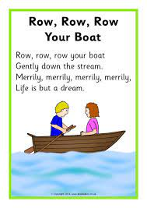
Maths  We will be consolidating all our number and maths skills this half term. We will be doing lots of subitising up to 5.  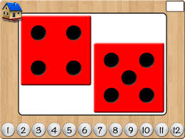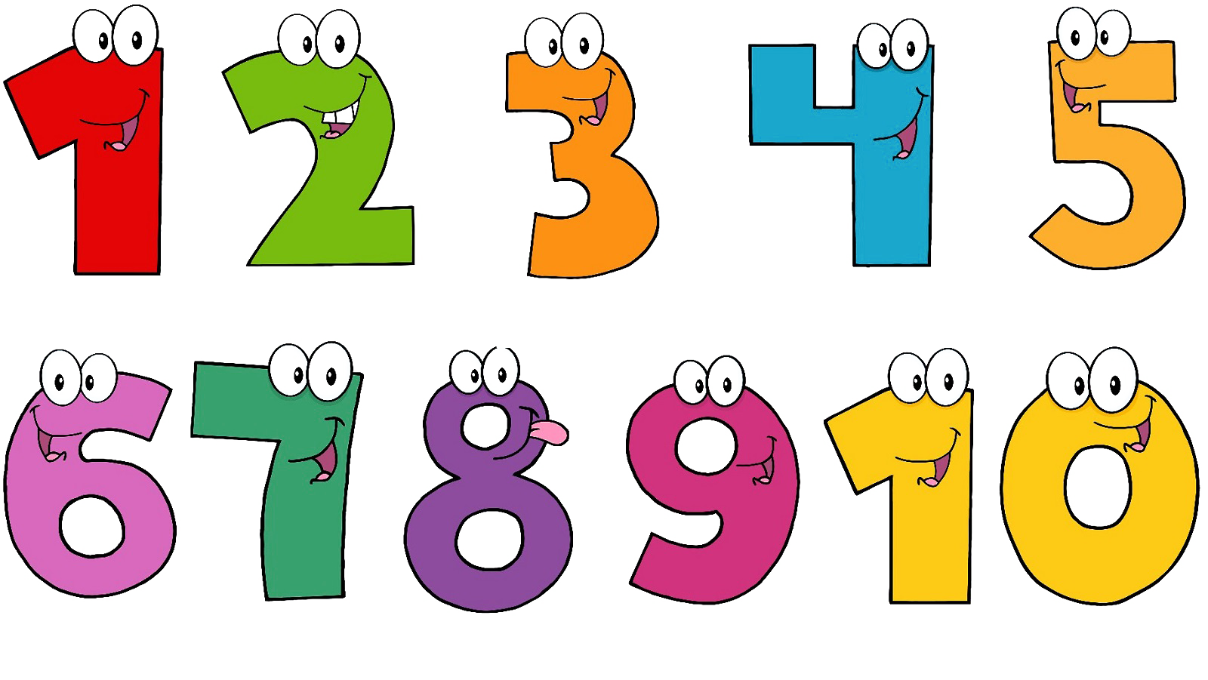 | Reminders  Don’t forget crickets sports day is on Thursday 3rd July. We will be practising our races in preperation for sports day.     | Phonics  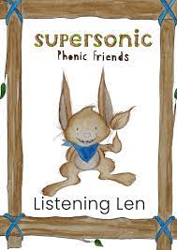  We will be embedding our phonological knowledge learnt so far. We will be doing lots of oral blending and playing fun phonics games.    

