English  We will be looking at different instructions and writing our own. | Maths  We will be learning about weight, looking at units of measure and then comparing. | PE  Our focus in PE in this half term will be multi-skills Please ensure your child has a full, named PE kit including joggers as we will sometimes be outside.
Music  We will be exploring musical sounds and how they can be changed focussing on timbre, dynamics and pitch. | .  Week beginning 13.4.26  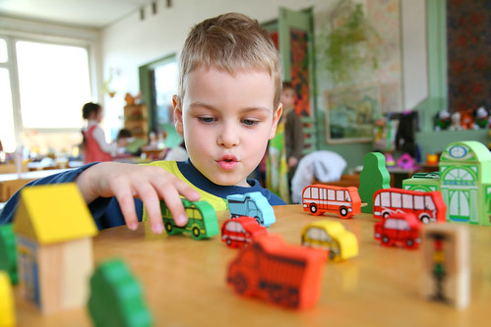 | Science  This week we will be planting seeds and discussing how they grow.
Poetry  We will be looking at classic Poems from our “Poetry Basket”.  This half term our poems are “Animals” |  | Art  We will be looking at the artists; Damien Hirst and completing different printing activities.
 | PSHE  This half term we are focusing on Me and My Family. | History  We will be looking at shops in the past and now and discussing the differences.
Phonics  We will be working through the Switch it Mitch sounds and tricky words. | PSHE  This half term we are focusing on Me and My Family.

