Question of the Week: What is wonderful about Wendover? WB: 19.05.25
  In Phonics we will be revising the Basic 3 and 4 spellings for the sounds, tricky words and high frequency words.  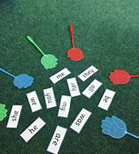 | In Handwriting, we will be revising the Lens Ladder letters  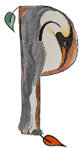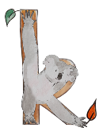  We will be recognising which letter family the letters come from and saying the ditties as we practice! |   In Writing, we are going to be recalling our language of ‘recounts’ to write about our Wendover Walk. We will be using the language of ‘First, Then, Next, After that, Finally’  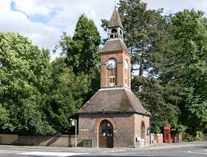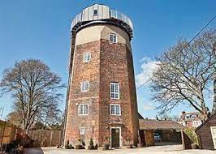 | Maths  In Maths, the children will be thinking about ordinality: considering where numbers to 10 are in relation to each other. The children will think carefully about which number is more or less whilst using playing with number tracks. We will also be using positional language to describe a location and when using the obstacle course.  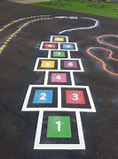  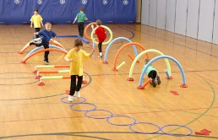
  Move, walk, stroll, ramble, hike, wander, wriggle  run zoom race speed dash  Curious Conversations  People should live in nests – is this a good idea?  Poetry Basket  Recalling all previous poems. | What is wonderful about Wendover?  This week the children will be taking part in a walk around Wendover. They will be thinking about how Wendover was different in the past. For example, how the windmill would have had sails and been a working mill.  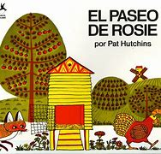  Our core text for the week will be -  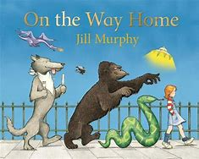  We will be reading:  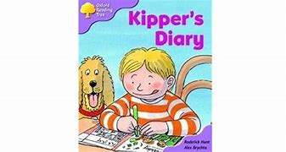  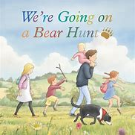 |  | Wendover Walk Trip  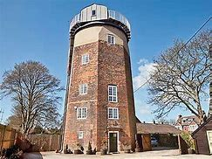  Monday 19th May 2025  Coats & Sunhats  Please ensure children have a waterproof coat and a sunhat everyday. Please apply sun lotion before school. Thanks.  Dates  Week beginning 26th May – Half Term  2nd June INSET Day

