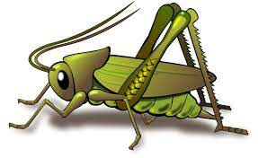
Value of the Week: Respect Autumn 2 Week 6
Activities based on the interests of the children….
This week we will be thinking again about our school value of Respect. We will be thinking about how to consider the feelings and rights of others.  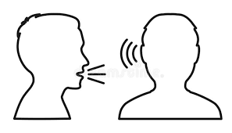  Our behaviour expectation for this week is Do Listen.  We will also be continuing to learn about how to look after our classroom and each other, to work hard and to be kind and helpful. | We will be listening to stories, rhymes and fairy tales.  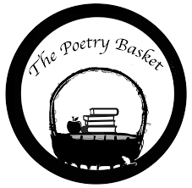  Our Poetry Basket Poem this week is:  I Can Build a Snowman  I can build a snowman,  I can build it high,  I can build a snowman,  Up into the sky.   | This week our core text is Goldilocks and the Three Bears.  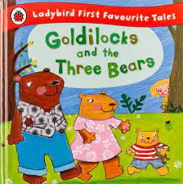  We will be developing our love of reading familiar stories from our classroom, retelling stories and reciting poems.  We will be singing the Nursery Rhyme ‘Twinkle Twinkle Little Star.’  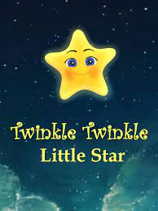
This week our Number Rhyme is  10 Fat Sausages    We will continue to subitise groups of objects (0-3). | We will be starting to make our Christmas crafts and applying all of our creative skills learnt so far.   | Listening Len is our supersonic phonic friend. With his help we are learning to be good listeners. In the classroom we have a puppet and we have learnt some new games which your children may tell you about.  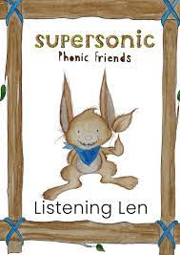  This week we be exploring Body Percussion. We will be distinguishing between sounds and remember a pattern of sound  Ideas for phonic activities at home:  Choose a story at home to read with your children. Ask the children to make body percussion sound effects to the story. Peace at Last is a perfect story for this sort of activity.

