English  This week we will be reading the book The Little Red Hen and writing about what animals appear in the story. | Maths  This week in Maths we working on addition. | PE  Our focus in PE in this half term will be multi-skills Please ensure your child has a full, named PE kit including joggers.
Music  We will be rehearsing our Harvest Festival Songs. We will be thinking about using our voices to create an effect. | Week beginning 5.10.25  Incredible Me!  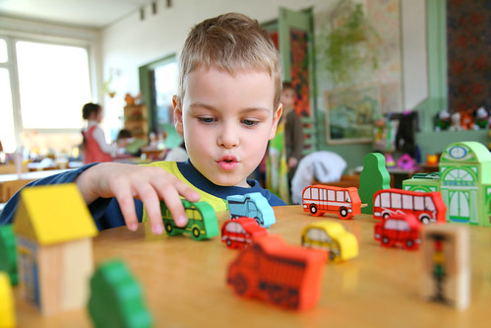 | Science  We will be investigating different senses.
Poetry  We will be looking at classic Poems from our “Poetry Basket”. |  | Art  This half term we are going to be looking at sketching and mark making in Art and using H and B pencils to create different effects.
 | PSHE  This half term we are focusing on safety at home. This week we will start thinking about what is/is not an emergency. | Geography  We will be learning about maps and looking at our school groups, drawing and making different maps.
Phonics
We will be recapping and reviewing Basics 4 and reading CVCC words.

