PE  May Pole Dance Prep  Mindful minutes   | ENGLISH  Traditional Tales: Children will be planning their innovated Traditional Tales using the skills acquired over the past few weeks.  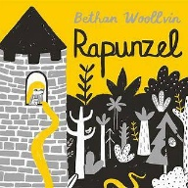  Helicopter Stories using Tales Toolkit.  SPAG / HFW / TW / CEW  HANDWRITING  Preparing and number thirty five, 35  PHONICS  Daily Phonics Sessions.  READING  Daily Story Sessions & Learn a Poem.  Remember to bring in reading books everyday. Please sign the diary when you have heard your child/ren read and indicate where you have read up to.  Guided Reading Comprehension. | 16.3.26  We will continue to focus on our school Behaviour Expectations & Values.  We will be reading:  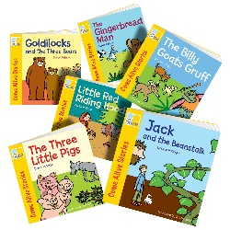  Traditional Tales | MATHS  Multiplication  The children will be looking at Arrays.  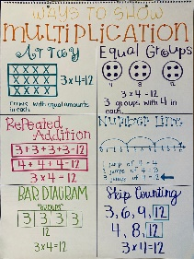 | MUSIC  A focus on singing expressively, playing tuned musical instruments, creative composing, responding to pitch changes and playing, creating and performing rhythmic patterns.  
ART / /COMPUTING  Printing ‘The Great Wave’ using foam boards, pens and water.  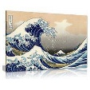  Blue bots  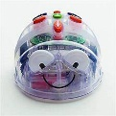 |  |  | HISTORY  The children are learning about the inspirational Mary Secole  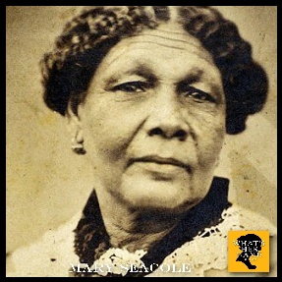  YOU MIGHT LIKE…  You could take a visit to Claydon House in Bucks. Florence was a regular visitor because her sister Parthenope lived there.  
DT
The children will make and evaluate their Puppets inspired by Joe the Puppet Man’s workshop.

PSHE  Behaviour Expectations & Values  Reflection  Circle Time  Friendship   |  | Homework    New homework was issued on 12.3.26 on Book Reviews and will need to be returned on 24.3.26. | FINE & GROSS MOTOR  Funky Fingers  Crossing the mid-line.  Further developing of cutting skills.  

