Question of the Week: What animal am I? / Where do I live? WB: 26.02.2024
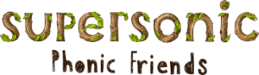  This week we will be learning the new spellings for the sounds  ure, ear, air  and new Tricky Tess words  little, out | Grandma Fantastic Words  Running chasing hunting  Walking strolling rambling | In Writing we will be going on a ‘jungle’ expedition and describing what we see. We will also be describing our favourite animal from the ‘Animal Workshop’.  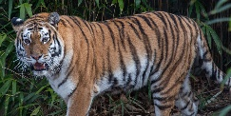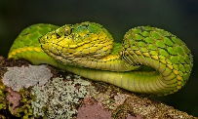 | Maths  This week the children will be learning the number 8 and considering where number 8 is in relation to one another.  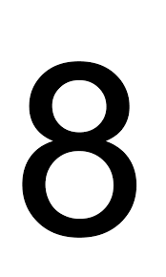
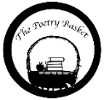  Pancakes by Christina Rossetti  Mix a pancake,  Stir a pancake,  Pop it in the pan.  Fry a pancake,  Toss a pancake,  Catch it if you can. | 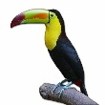  Our topic is Explorer, Explorer – Animal  Walking Through The Jungle  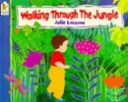  What animal am I?  We will be thinking about the features of an animal, for example what animal has orange and black stripes and big teeth? We will be exploring a range of non-fiction books about animals and their habitats.  Where do I live?  We are looking at where different animals live and their habitats, and why they might need to live there, and not in other places. What would happen to a polar bear in the savannah? Or a lion in the ocean?  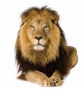 |  | Tuesday 27th February  Animal Workshop  We are lucky to have our ‘Animal Workshop’ next Tuesday where the children will have the opportunity to see and hold a variety of animals. I am sure they will be excited to share their learning with you.  