Question of the Week: Why do animals have patterns? Why do some animals change colour? WB: 11.03.2024
This week we will be revising the spellings for the sounds:  ch sh th ng ai ee igh oa  We will also be focusing on reading our Tricky words and our High Frequency Words and reading these with speed. | In Handwriting, we will be continuing to focus on Len’s letters 2  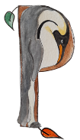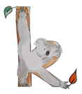  We will be recognising which letter family the letters come from and saying the ditties as we practice! | In Writing, we will be thinking about whether we would rather be an animal in the wild or a pet belonging to a child and why.  We will also be focusing on writing our Tricky words and our High Frequency Words. | Maths  This week we will be identifying equal and unequal numbers and looking at doubling numbers.  We will be thinking about how two equal parts make a whole.  Our STEM sentence will follow the structure below:  Double 2 = 4  Double 2 equals 4
The Fox  The fox is smart,  And sly as can be,  And a great big bushy tail has he.  He can run very fast,  And his fur is red,  And he lives in the woods in his tree  trunk bed.  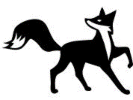 | Our topic is Amazing Animals –  Why do animals have patterns? Why do some animals change colour We will be reading  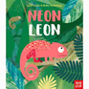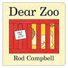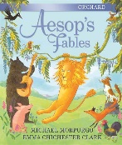  We will be creating animal camouflage pictures using pastels or water paints. We will be reflecting and seeing what we can do to make them even better.  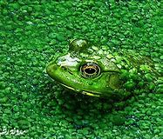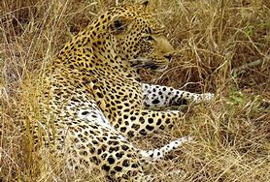  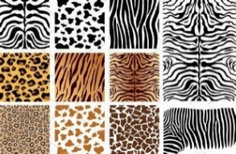  We will be exploring why animals have different patterns and how they help keep them safe. |  | Library Visit  Caterpillars – 21st March  Honeybees – 22nd March  Ladybirds – 28th March  Don’t forget to wear appropriate coats.  ******  Reading.  Please listen to your child read every day and sign to say you have heard them.  It is so important that children are reading regularly to help them embed and consolidate the learning they are receiving at school. Thank You

