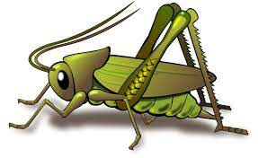
Spring 1 Week 5
Question of the Week: How do you celebrate in your family?
Activities based on the interests of the children….
This week’s NELI story is “Don’t Wake Up Tiger” by Britta Teckentrup  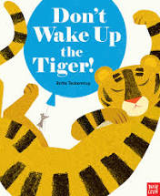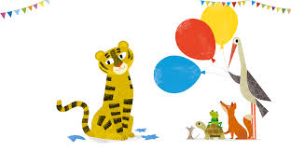  We will be developing our communication and language with special words throughout the week. We will learn about tigers, floating and sinking and there will pretend birthday parties with plenty of opportunities to write recipes, menus and shopping lists.  We would love to hear if your child tells you about the new words that they have learnt. |   Our Poetry Basket Poem this week is…  A Little House  I’m going to build a little house,  With windows big and bright,  And chimneys tall with curling smoke,  drifting out of sight.  In winter when the snowflakes fall,  Or when I hear a storm,  I’ll go and sit in my little house,  Where I’ll be snug and warm. | Conversation starter – Would you rather be chased by a friendly tiger or a grumpy mouse?  We will be singing the Nursery Rhyme Twinkle Twinkle Little Star  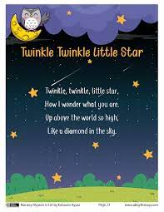  This week our Number Rhyme is  3 Blind Mice  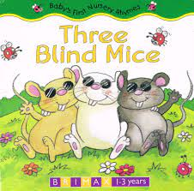
In maths we are using our number sense to partition and separate amounts/ numbers into part/whole. We are already very good at saying what we see when we are subitising. We will be separating a group of 3,4,or 5 in different ways, recognising that totals are the same.  I see 3 and 2  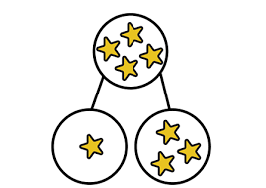 | We will be experimenting with shaving foam marbling, mixing orange and black paint into shaving foam to create a marble effect.   | 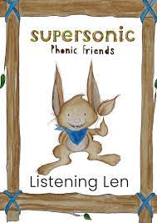  This week we will be embedding our understanding of rhyme and alliteration. We are listening carefully to sounds and beginning to distinguish between the initial sounds for Alliteration and the end sounds for Rhyme. We will also be listening to Voice Sounds.  Ideas for alliteration activities at home:  For alliteration play Listening Len goes to the Zoo. Have a selection of toy animals to hand. Adults models. He sees a slithering, strong, snake, a terrible, tall, talking tiger, etc  Ideas for voice sounds activities at home:  When you are out and about, ask your child about the sounds things around them make, for example “What sound does a clock make?” – tick tock, tick tock,. “What sound does a train make?” – ch, ch, ch, ch,ch, “What sound does a bee make?” - zzzzzzzzzzzzz

