Question of the Week: Which animals make good pets?
WB: 04.03.2024
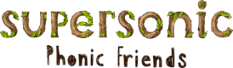  This week we will be revisiting the sounds  j, v, w, x  y, z, zz, qu  Tricky words  little, out | In Handwriting, we will be continuing to practise Len’s Ladders letters we have been learning in Phonics.  h, b, p, k  We will be recognising which letter family the letters come from and saying the ditties as we practice them! | In Writing we will be learning to write instructions and character descriptions.  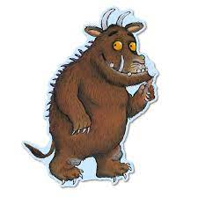 | Maths  The children will be exploring the composition of numbers in particular they will be investigating the number 7.
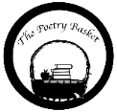  Wise Old Owl  A Wise old owl sat in an oak,  The more he heard, the less he spoke.  The less he spoke, the more he heard.  Why aren’t we all like that wise old bird?  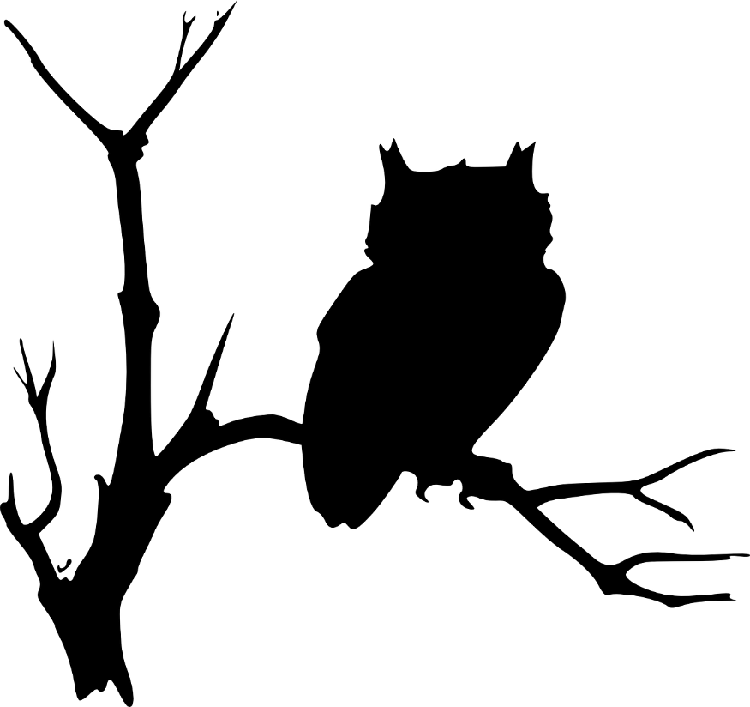 | We will be reading  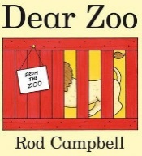  We will be using the ‘Explorify Webiste to develop childrens langauge and communication skills through scientific discusion through the Zoom in Zoom activity. Can children quess what it is?  We will also be thinking philosophically to think about what animals do and don’t make good pets?  What you rather have a goldfish or a pirahna? Can you say why? | Reading  Just a reminder, please ensure you hear your child read every day. This can be with their tricky words, high frequency words, sounds, reading books or poems.  Basic 3  Basic 2 | World Book Day  Thursday – Please bring a book for your child to swap  Friday – Dress up as your favourite book character and bring in the book. Please name!  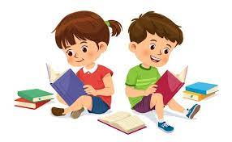  Animal Magic  The children had an amazing time seeing all the animals last week which we are sure you have heard all about. If you have not yet made a contribution we would be very grateful if could.

