PE    Dancing    Mindful minutes | ENGLISH  Children will continue to read the story of The Lost Homework. They shall look at ways of expanding their sentences and begin to plan their writing based on something they have lost.  .  The Lost Homework  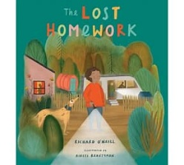  SPAG / HFW / TW / CEW. Reading comprehension  HANDWRITING  Diagonal Joining patterns  PHONICS  Daily Phonics Sessions.  READING  Daily Story Sessions & Learn a Poem.  Remember to bring in reading books and diaries every day. Please sign the diary when you have heard your child/ren read.  Guided Reading: Comprehension Strategies. | 11.5.26  We will continue to focus on our school Behaviour Expectations & Values.  We will be reading:  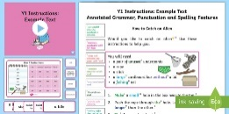  Narrative Texts & Reading Comprehensions | MATHS  Addition and Subtraction  Children to recap their skills based on addition and subtraction.  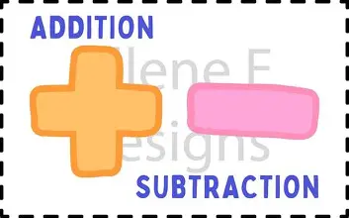 | MUSIC  To use movement to respond to pitch and recognise a notes relationship to another using higher & lower. To recognise high, mid and low-pitched sounds and use graphic notation to represent pitch. To pitch match simple phrases and explore vocal timbre.  To play ascending and descending melodies on tuned percussion. To compose & notate a short composition using graphic notation and recognise and describe changes in pitch  
ART – SEWING  Children will use various stitches to create a tasselled bookmark.  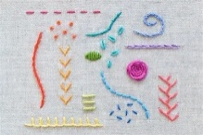  COMPUTING  Blue bots |  |  | SCIENCE  The children will be learning about Plants. They will be focusing on the life cycle of a plant.  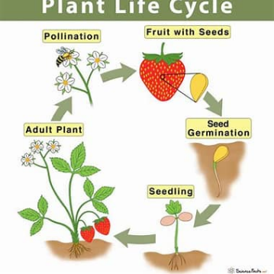
PSHE  Behaviour Expectations & Values  Reflection  Circle Time  Family   |  | Homework    New homework will be based on instruction writing and was issued on 30/4/26. It needs to be returned on 12.5.26  If there is an issue with completing it on time, do speak to your child’s teacher. | FINE & GROSS MOTOR  Funky Fingers  Crossing the mid-line.  Further developing of cutting skills.  