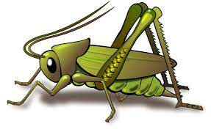
Spring 2 Week 5
Theme of the week – The life cycle of a duck
Activities based on the interests of the children….
This week’s story is ‘The Boy and the Bear’ by Tracey Corderoy  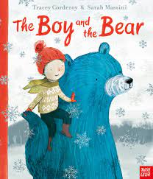  We will be thinking about our School value of Good Manners and how to treat others with courtesy and politeness and behave well towards them.   |   Our poem this week is called:  A Little Seed  A little seed for me to sow,  A little soil for it to grow.  A little hole, a little pat,  A little wish, and that is that.  A little sun, a little shower,    A little wait, and then a flower. | This week we will be revisiting how we can practise our mark making in different areas of the classroom and when we are learning outside. For example, when we are learning in the home corner we might role play ‘home’ activities including cooking/writing recipes, making phone calls and writing down the messages or writing shopping lists.  
This week’s number rhyme is ‘Five Little Ducks’  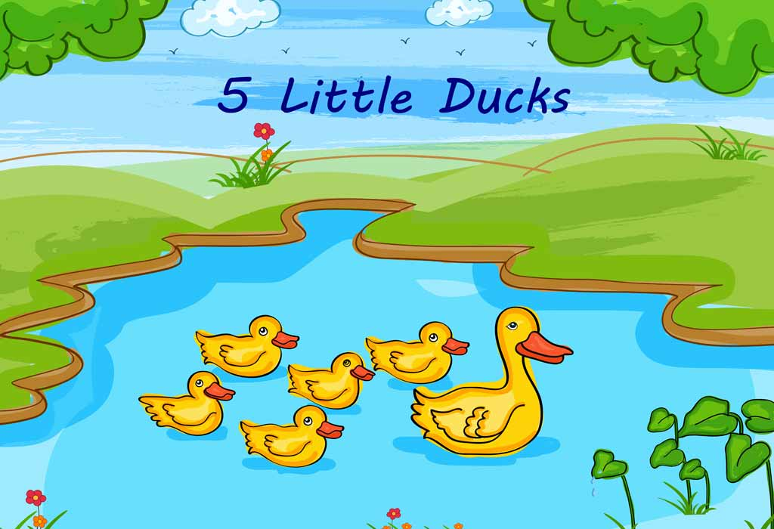 |   This week we will be continuing to develop our ‘Phonological Awareness’ by listening to “robot talk” for a word and then identifying the correct word. E.g. I say c -a – t. Can you point to that picture?  Ideas for phonic activities at home:  When you are asking your child to do something, break down one of the words, but ensure it only has 3 parts. E.g. Can you pull up your z – i - p?  Can you get your c – oa –t ?  Please can you clean your t – ee - th? | We will be continuing to observe the spring flowers that are growing in our Cricket’s garden and will be planting some seeds.  We will look at the life cycle of the duck.  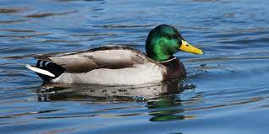  We love receiving and celebrating those WOW stars so keep them coming in! Thank you.  

