English  This week we will writing a character description using adjectives and similes and putting it into a tales tool kit story. | Maths  We will be measuring length and height and beginning to record. | PE  Our focus in PE in this half term will be multi-skills Please ensure your child has a full, named PE kit including joggers as we will sometimes be outside.
Music  We will be exploring musical sounds and how they can be changed focussing on timbre, dynamics and pitch. | Week beginning 16.3.26  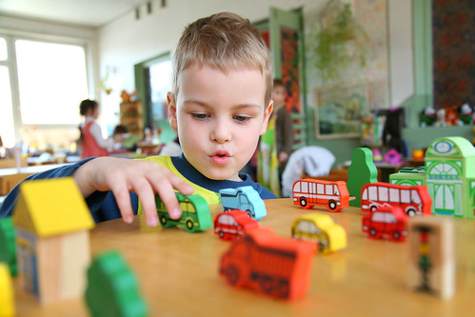 | Science  This week we will be looking at mammals, birds and fish and their features. How do we know why they fit into each category?
Poetry  We will be looking at classic Poems from our “Poetry Basket”.  This half term our poems are “Space” |  | Art  This half term we will be working on mixing of primary colours.
 | PSHE  This half term we are focusing on friendships, diversity and communities.  Our value of the week is independence. | History  We will be looking at different kings and queens that have ruled England in the past.
Phonics
We will be working through the Switch it Mitch sounds and tricky words.

