AUTUMN TERM 2025

September
5th PTA breakfast after drop off
9th PTA breakfast before drop off
16th Crickets induction meeting 9.00 am
Red Kites induction meeting 2.30 pm
Herons induction meeting 2.30 pm
17th Hedgehogs induction meeting 2.30 pm
Badgers induction meeting 2.30 pm
Squirrels induction meeting 2.30 pm
Firecrests induction meeting 2.30 pm
18th Ladybirds induction meeting 2.30 pm
19th Honeybees induction meeting 2.30 pm
Caterpillars induction meeting 2.30 pm
22nd Wendover Music Mini Mozart 9.15 – 10.00 am
24th FS 9.00 phonics meeting and 9.30 am Harvest Festival
26th KS1 Harvest Festival 9.30 am

October
7th Open morning for prospective EY (Nursery)
& FS (Reception) parents at 9.15am
14^{h} Parents evening 3.30 – 5.30 pm
15th Parents evening 3.30 – 5.30 pm
16th Parents evening 3.30 – 5.30 pm
20th Growth Mindset week
23rd Open morning for prospective EY (Nursery)
& FS (Reception) parents at 9.15am
24th School finishes for half term at 3.15 pm

November
3rd School re-opens after half term
Safety week
10th Health week
19th Open morning for prospective EY (Nursery)
& FS (Reception) parents at 9.15am

December
2nd EY Nativity 9.30 am
FS dress rehearsal 10.30 am
3rd FS Nativity 9.30 am
4th FS Nativity 9.30 am
5th INSET DAY
8th SEN reviews
9th SEN reviews
15th Year 1 dress rehearsal at 9.30 am
Year 2 dress rehearsal at 11.00 am
16th Year 2 performance at 9.30 am
Year 1 performance at 2.00 pm
17th Year 1 performance at 9.30 am
Year 2 performance at 2.00 pm
18th Christmas parties
19th School closes for holidays at 1.00 pm

SPRING TERM 2026

January
1st to 4th School Holidays
5th School re-opens

February
3rd Parents evening 3.30 – 5.30pm
4th Parents evening 3.30 – 5.30 pm
5th Parents evening 3.30 – 5.30 pm
9th Assessment week
Discovery week
12th School finishes for half term at 3.15 pm
13th INSET DAY
23rd School re-opens after half term
Arts week

March
2nd World Book Week
Communication Week
6th World Book Day Celebration
16th SEN reviews
17th SEN reviews
19th Phonics meeting for Y1 parents at 2.30 pm
20th Red Nose Day
23rd Assessment week
26th School closes for holidays at 1.00 pm
27th INSET DAY

SUMMER TERM 2026

April
13th School re-opens
30th May Day rehearsal at 9.30 am

May
1st May Day for Year 2 parents at 9.30 am
4th Bank Holiday Monday
11th – 14th SATS week
18th Assessment week
22nd School finishes for half term at 3.15 pm

June
1st INSET DAY
2nd School re-opens after half term
World Weeks from 2nd to 12th June
8th Phonics check
22nd Assessment week
26th FS/KS1 Sports Day

July
3rd FS/KS1 reserve Sports Day
6th Introduction meeting – new to EYFS at 7.00 pm
SEN reviews
7th County Induction Day
SEN reviews
9th Open Evening
10th Reports sent home
15th FS Celebration Assembly 2.30 pm (class tbc)
16th FS Celebration Assembly 2.30 pm (class tbc)
17th FS Celebration Assembly 2.30 pm (class tbc)
21st Year 2 Leavers rehearsal
22nd Leavers assembly for Year 2 classes (details tbc)
School closes for holidays at 1.00pm



THE JOHN HAMPDEN SCHOOL
WENDOVER

PLEASE RETAIN THIS CALENDAR FOR REFERENCE

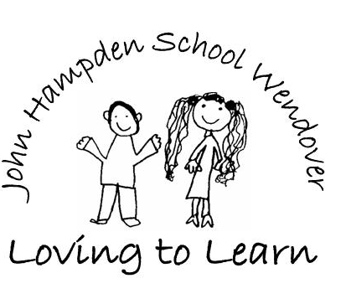

SCHOOL CALENDAR

September 2025 – July 2026

