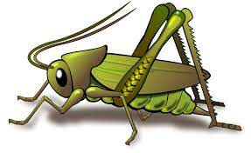
Summer 2 Week 3
World Week 2 – Kenya
Activities based on the interests of the children….
World week  We will be continuing to develop curious minds and learning about the world. This week we will be using our expeiences of travelling to different countries and exploring what life is like in Kenya. We will be making comparisions.  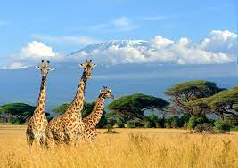  Conversation starters: What is it like in Kenya? How is it different to Wendover? | Poetry basket  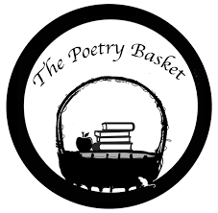  Our Poetry Basket Poem this week is;  Five Little Owls  Five little owls in an old elm tree,  As fluffy and puffy as owls could be.  Blinking and winking their big round eyes,  At the big round moon that hung in the skies.  As I walked beneath, I could hear one say,  “They’ll be mouse for supper, there will be today.”  Then all of them hooted, “Tu-witt, tu-whoo.  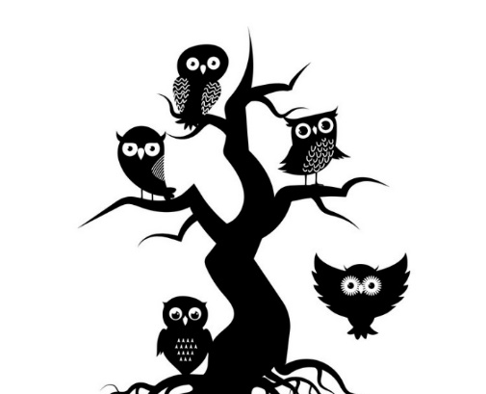  Yes, mouse for supper, Hoo-hoo. Hoo-hoo.” | Our rhymes  Our Number rhyme this week is ‘Hickory Dickory Dock’  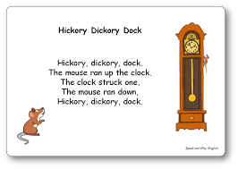  Our Number rhyme is ’10 Fat Sausages’  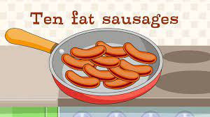
Maths  We will be consolidating all our number and maths skills this half term. Doing lots of subitising and counting. We will also be looking at creating simple patterns.  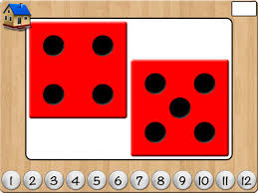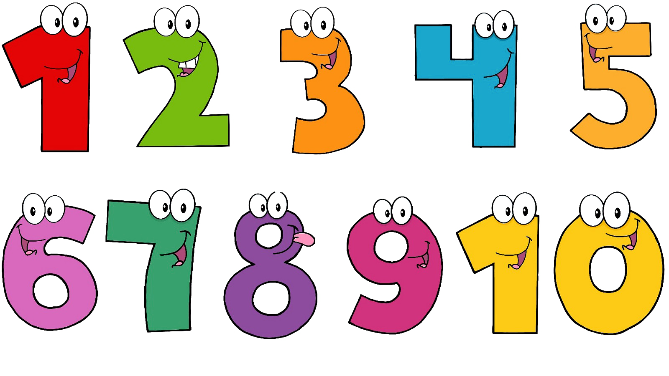   | Expressive arts and design  We will be listeninng to some african music and having a go at some african dancing. We will also be doing some painting of some animals that live in Kenya.  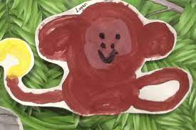  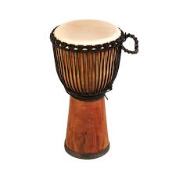   | Phonics  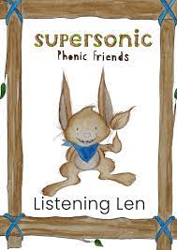  We will be embedding our phonological knowledge learnt so far. We will be doing lots of oral blending and playing fun phonics games.  