PE  A focus on multi skills including co-ordination, balance, agility, teamwork and safety.  Mindful minutes  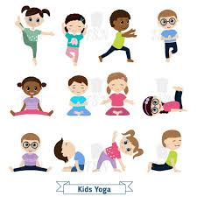 | ENGLISH  Writing dictation sentences about Health & instructions for a healthy snack  HANDWRITING  Number Handwriting and words containing Curly Cal, Lens Ladder or Zig Zag Letters  PHONICS  Daily Phonics Sessions  READING  Daily Story Sessions including Helicopter Stories, Tales Toolkit Stories and Talk for Writing & Learning Poems.  Remember to bring in reading books and diaries every day. Please sign the diary when you have heard your child/ren read. | 10.11.25  This week it is…  HEALTH WEEK  We will be reading…  A range of PSHE books related to Health including  Mama Panya’s Pancakes by Mary Chamberlin  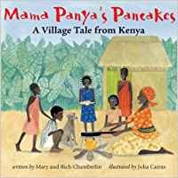 | MATHS  Number  Place value, Representing Numbers  Using a variety of manipulatives to represent a given number.  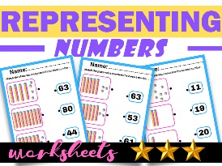 | MUSIC  Songs & rhymes  
COMPUTING

Purple Mash Health Activities

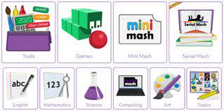

HEALTH WEEK ACTIVITIES AT SCHOOL  Daily exercise  Family Fun Fitness  Staying Healthy  Football Sessions with John Colet School  Importance of Exercise  Zumba Dance Sessions WJS Students  Handwashing  Zones & Calming Strategies  Keeping my body well / keeping clean – Dr Ranj  Mouldy Bread Experiment  Relaxation & Calming Down Techniques  D&T Making A Healthy Snack  Dance Squad Demo John Colet School  Yoga / Jo Wicks  Relaxation & Calming Down | PSHE    Behaviour Expectations & values linked to Health Week  With a focus on the importance of staying healthy and associated vocabulary. | HEALTH WEEK ACTIVITIES AT HOME  Perhaps your child/ren could do the following at home:  - Dance party  - Obstacle course  - Yoga  - Gardening  - Mindfulness Activities  - Cook together | HOMEWORK    New homework was issued on 6/11/25 and needs to be returned by 18/1125.  They need to create a homework linked to Firework Safety. | FINE & GROSS MOTOR  Funky Fingers:  Cutting Skills  Crossing the mid-line  