English  This week we will be continuing our unit on ‘Stop, that’s not my story’. | Maths  This week in Maths we will be working on addition and subtraction. | PE  PE day will remain a Wednesday and wear your PE kit to school. We will also be practicing our Christmas dance on a Thursday, please just come to school in your uniform.
Music  We will be rehearsing songs ready for our Christmas Nativity. | Week beginning 9.11.25  Incredible Me!  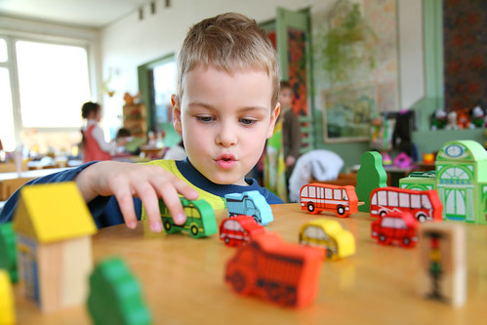 | Art  This half term we are going to be looking at how to use watercolours. We will also be looking at the artists Van Gogh and Paul Klee.
Poetry
We will be looking at classic Poems from our “Poetry Basket”.
We will look at poems from last year that we already know and new poems for year 1.

 | PSHE  This half term we are focusing on keeping healthy. Looking at healthy food, looking after our teeth, the importance of exercise and having enough sleep. | History  We will be looking at how to stay safe with fireworks.
Phonics
We will be starting our Choose to Use phonics this term. There are new sounds and new tricky words.

