

**Our E-Safety Charter**

**(This will help me to stay safe and healthy online)**

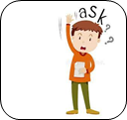I promise …

* To ask an adult if I want to use a device.



* To only use activities and websites that an

adult has explained and allowed me to use.



* To only click on buttons and links when I have  
  been shown what they do.

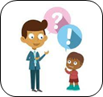

* To ask for help from an adult if I am not sure what  
  to do or if I think I have done something wrong.



* To tell an adult if I see something that upsets me   
  on the screen and to turn the device over.
* 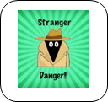Never to share any personal details or photos with  
  anyone online as people might not be who they say  
  they are.

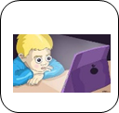

* To remember that it is not healthy for me to spend

too much time online.

I know that if I break the rules I might not be allowed to use the computing equipment.