What We Are Learning: Autumn 1 Week 4

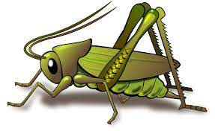
Value of the Week: Collaboration
Activities based on the interests of the children….
We are learning about the JHSW Values and Behaviour Expectations. We have already thought about being the best that we can be, belonging and perseverance.  This week we will be thinking about Collaboration – We will be learning what it means to collaborate so that we can work with someone else to achieve or do something.  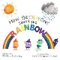  We will also be continuing to learn about how to look after our classroom and each other.  Our behaviour expectation for this week is Do be kind and helpful.  Kindness cups will be awarded to those children who are spotted being kind and helpful to one another. | We will be listening to stories, rhymes and fairy tales.    We will also be learning our second poem from Poetry Basket. This is a special rhyme and movement activity we do during our morning sessions. It is great fun and features a range of seasonal and classic poems. See if your child can recite our first poem to you. It is called Chop Chop.  Wise Old Owl  A wise old owl sat in an oak,  The more he heard, the less he spoke.  The less he spoke, the more he heard.  Why aren’t we all like that wise old bird?  We would love you to share these poems with your child each week. | Our theme for the term is ‘This is Me’.  Our aim is that all children feel happy, safe and welcome in Crickets. Each child is individual and their learning journey is unique.  This week we will be talking about ourselves and families and getting to know each other!  This all fits in with the school ethos of Being the Best That We Can Be.  We will begin to teach children how to self-regulate and understand their feelings.  This week our key story books are ‘Stick and Stone’ by Beth Ferry, ‘Kindness is my Superpower’ by Alicia Ortego and ‘How the Rainbow saved the crayons’ by Monica Sweeney.
This week our Number Rhyme is 5 Speckled Frogs  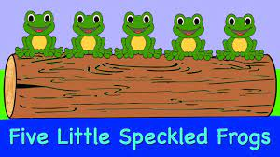 | We will be playing “Bug in a rug” and “Simon Says”  Games like this help us to improve our listening skills and teach us how to work as a team.  We will be singing the Nursery Rhyme “Baa Baa Black Sheep”  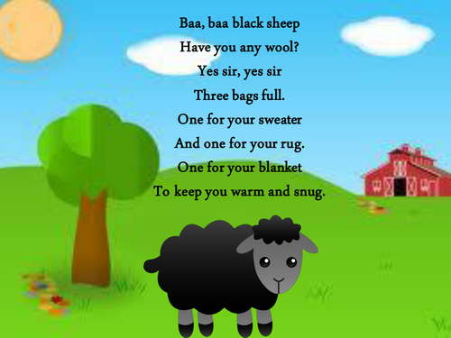 | We will be starting our mark making journey by making different marks outside using big up/down arm movements in readiness for leaning the pre writing pattern I.  