PE    Dancing    Mindful minutes | ENGLISH  The Lost Homework children to begin to write, check and publish  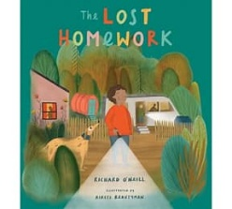  SPAG / HFW / TW / CEW. Reading comprehension  HANDWRITING  Long Diagonal Joining Patterns  PHONICS  Daily Phonics Sessions.  READING  Daily Story Sessions & Learn a Poem.  Remember to bring in reading books and diaries every day. Please sign the diary when you have heard your child/ren read.  Guided Reading:  Narrative | 18.5.26  We will continue to focus on our school Behaviour Expectations & Values.  We will be reading:  Narrative stories to entertain. | MATHS  To explore the properties of 2D and 3D shapes.  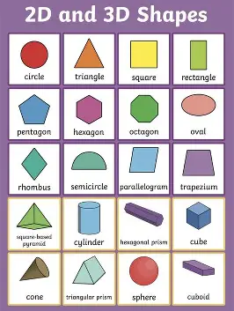 | MUSIC  To use movement to respond to pitch and recognise a notes relationship to another using higher & lower. To recognise high, mid and low-pitched sounds and use graphic notation to represent pitch. To pitch match simple phrases and explore vocal timbre.  To play ascending and descending melodies on tuned percussion. To compose & notate a short composition using graphic notation and recognise and describe changes in pitch  
ART – SEWING  Children will use various stitches to create a tasselled bookmark.  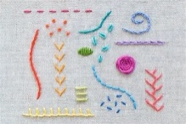  COMPUTING  Blue bots and how to programme them. |  |  | SCIENCE  The children will be learning about Plants. They will be focusing on fascinating plants and will design their own plant.  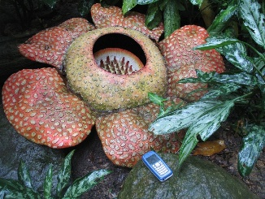
PSHE  Behaviour Expectations & Values  Reflection  Circle Time  Family   |  | Homework    No new homework this week.  . | FINE & GROSS MOTOR  Funky Fingers  Crossing the mid-line.  Further developing of cutting skills.  