WB: 8.9.25 | Value: Perseverance | Behaviour Expectation: Do work hard
Question of the Week: What are the different parts of the body called?

We will be reading the stories:  Tilda Tries Again by Tom Percival  https://www.youtube.com/watch?v=iQFae4BKaUI  The Magical Yet by Angela DiTerlizzi  https://www.youtube.com/watch?v=F6QLt4092_Y  Flight School by Lita Judge  https://www.youtube.com/watch?v=jcHy4RSAkbM | Grandma’s Fantastic Words  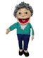  brave courageous  scared petrified  Please use these words in a variety of different contexts for example:  “You felt brave when you went into your new class.”  “You were courageous when you helped your friend climb the tree even though you were nervous.”  “You were scared when you heard a loud noise in the middle of the night, but you remembered it was just the wind.”  You felt petrified when you saw a big spider in the bathroom, but you called for help.” | Poetry Basket Poem  Chop Chop  Chop chop choppity chop  Cut off the bottom and cut off  the top.  What there is left, just put  in the pot.  Chop chop choppity Chop | Squiggle Whilst You Wiggle:  Squiggle Dance 1 is Walking on Sunshine  We will learn the big movement down and up, starting with down. Down up down up.  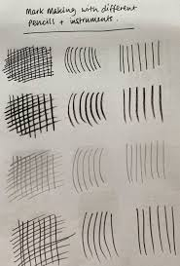  We will learn to write Len’s Ladder letter ‘l’  “Down the ladder and curl around.”  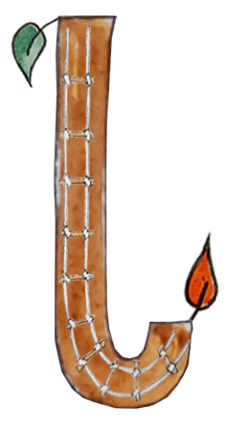
  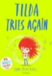 | 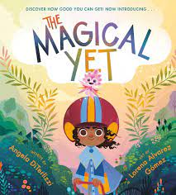 | 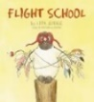
  Honeybees story | Ladybirds story | Caterpillars  Story
Curious Conversations:
Would you rather be big or small?
(This is a question for discussion. When answering the question, we encourage children to answer in sentences using the words in the question. This is called ‘recasting.’ This technique helps children develop their language skills by providing them with a clear example of how to form complete sentences. It reinforces sentence structure and encourages more detailed and thoughtful responses. “I would rather be……because….)
Phonics  We will be playing oral blending games – saying touch your t-oe-s etc point to your b-r-ai-n .  We will be reading rhyimng stories and making rhyming strings inclusing nonsense words – Len, Ben, pen, den, hen, ten, fen,gen, ren,sen. | Our value this week is -  Perseverance    To keep on putting in effort to achieve something, even if is challenging  The children will demonstrate in a variety of ways different levels of perseverance throughout their learning this week including .  Our behaviour expectation this week is: Do work hard |  | Tales Toolkit  We will be continuing to introducing Tales Toolkit symbols. This week we will focus on the part of the story before something happens which is called ‘the build up’. When the children see this symbol they need to say “One day.”  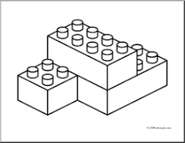  We will be adding ‘One day’ into our story telling so far.

To answer the questions of the week What are the different parts of the body called? we will be singing ‘Heads, shoulders , knees and toes, “ and adding in other body parts - neck, arms, hands, fingers, tummy, back, bottom, legs, feet, brain. We will be looking at similarities and differences between ourselves  .  We will be starting our ‘Growth Mindset Journey’ by learning some of the different ways to look after and grow our brain:  - Exercising our brains (puzzles and problem solving)  - Looking after our brains (sleeping, eating healthily and drinking water)  - Challenging ourselves  - Being positive ( I can…I can’t do it yet.”)  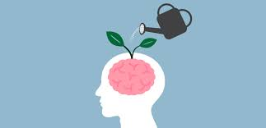 | We will be learning how to join using glue sticks, cellotape and masking tape in a dispenser and exploring why we use the different joining techniques. | We will be experiment with different art pencils and show how Vincent Van Gogh used lines to made marks.  The Sower  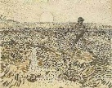
  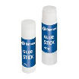 |  | 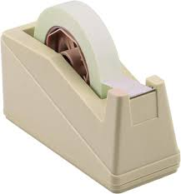
  glue stick | sello tape | masking tape
Please share Library Book Club
