Question of the Week: Why do animals have patterns? Why do some animals change colour? WB: 16.03.2026

  This week we will be revising the spellings for the sounds:  ear, air, ure  We will also be focusing on reading our Tricky words and our High Frequency Words and reading these with speed. | In Handwriting, we will be continuing to focus on Curly Cal’s  letters:  c o a  We will be recognising which letter family  the letters come from and saying the  ditties as we practice!  Remember to reference correct letter formation via the videos on the padlet! |   In Writing, we will be thinking about whether we would rather be an animal in the wild or a pet belonging to a child and why.  We will also be focusing on writing our Tricky words and our High Frequency Words. | Maths  This week we will be continuing to learn number bonds to 5 and extending number bonds to 10.  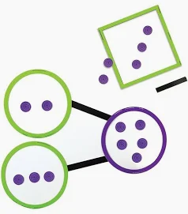
The Fox  The fox is smart,  And sly as can be,  And a great big bushy tail has he.  He can run very fast,  And his fur is red,  And he lives in the woods in his tree  trunk bed.  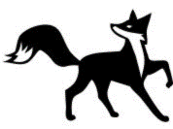 | Topic  Why do animals have patterns? Why do some animals change colour? We will be reading  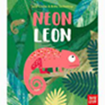  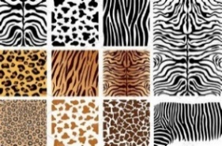  We will be creating animal camouflage pictures using pastels or water paints. We will be reflecting and seeing what we can do to make them even better.  We will be exploring why animals have different patterns and how they help keep them safe. |  | Comic Relief  Friday 20th March    MUFTI Day—wear something red.

