WB: 22.9.25 | Value: Good Manners | Behaviour Expectation: Do be polite. Do be gentle.
Question of the Week: What can we use our hands and sense of touch for?


We will be reading the story:  Dogger by Shirley Hughes  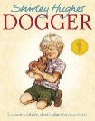  https://www.youtube.com/watch?v=ZB3UVAVtbIs | Grandma’s Fantastic Words    worried anxious fretful  confident positive  Please use these words in a variety of different contexts for example,  “I felt anxious when I had to go to the dentist for the first time.  I was fretful when I couldn't find my favourite book before bedtime.  I stayed positive even when it started raining on our picnic because I knew we could still have fun indoors.” | Poetry Basket Poem  A Cup Of Tea  Here’s a cup,  And here’s a cup,  And there's a pot of tea.  Pour a cup,  And pour a cup,  And have a drink with me. | Squiggle While You Wiggle:  We are revisiting Squiggle Dance 1 I’m In The Mood For Dancing. We will learn the big movement down up, left and right. We will learn how to draw squares and rectangles.  We will practise pre-writing  shapes I - + and learn cross  hatching.  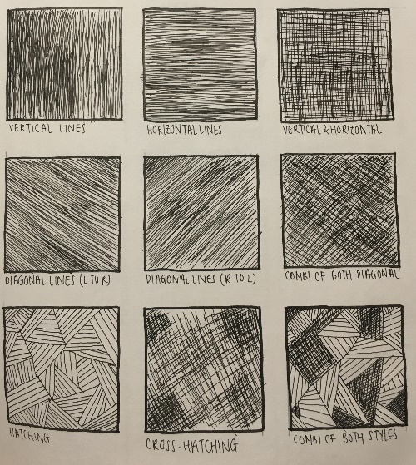
Curious Conversations:
Would you rather?

I would rather….because…

Phonics  We will learn about syllables.  We will be learning the spellings for the sounds:  i n m d  We will be learning to read the tricky words is and I and the high frequency words in, it, dad, and, on  Please see Parents Phonics Newsletter for further details | Our value this week is -  Good Manners  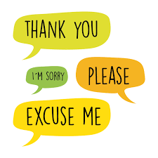  To treat others with courtesy and politeness and behave well towards them  The children will demonstrate in a variety of ways different levels of good manners throughout their learning this week including .  Our behaviour expectation this week is: Do be polite. Do be gentle |  | Tales Toolkit  We will be continuing to introducing Tales Toolkit symbols. This week we will focus on story starts.
   | Once upon a time  A long time ago

To answer the questions of the week What can we use our hands and sense of touch for?, we will read ‘The Magic Paintbrush’ and then experiment using a range of different brushes to paint – thick, thin, long and short.  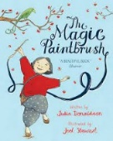 | To answer the questions of the week What can we use our hands and sense of touch for?, We will explore feely boxes and ask children to guess what they can feel.  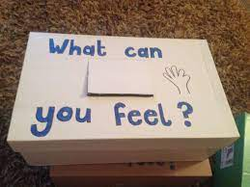  We will then ask how do they feel? and use the vocabulary:  Hard/soft  Bendy/ stiff  Smooth/rough  Fluffy | In Maths we will continue to subitise as it is important to continually practise this skill with a variety of objects and arrangements.. We will ask children to pick up the same objects in their hand and ask “What can you see?”  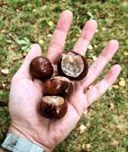  Drop the objects gently and ask “What can you see and how do you see it?”  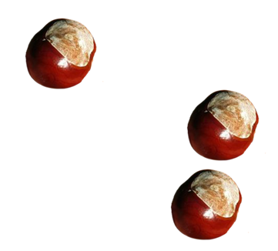” I can see 1, I can see 2. I can see  3 altogether.”
We will explore the purpose of counting and practise counting things that you cannot see, for example claps or beats on the drum.  We count to measure time, for example we will count up to 10 and see if we can all get into a circle by the time we have reached 10. | We will learn how to make marks in maths and then we will learn how to make a tally when we are using ‘The Lookout’ to observe the ducks and moorhens.  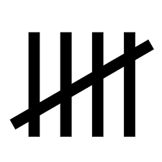 | We will be using our pop up shop to buy a variety of things. Prices will be 1p, 2p or 3p and we will use 1p coins.  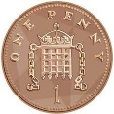
Finger numbers. We will be playing a game where we listen for a number and show the amount of fingers.  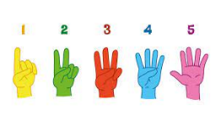 | We will continue to explore different ways to join. This week we will learn how to use a hold punch and treasury tags.  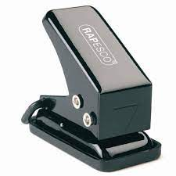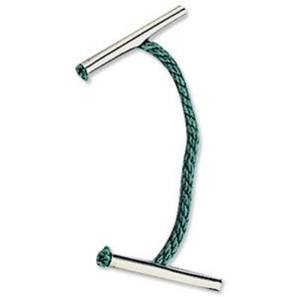 | Please share Library Book Club  

