WB: 25.11.24 | Value: Good Manners | Behaviour Expectation: Do be polite. Do be gentle.
Question of the Week: How Many Colours Can You See Around You?

We will be reading the story:  The Day The Crayons Quit  By  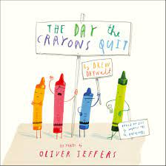  https://www.youtube.com/watch?v=gPkrhIEoOJg | Grandma’s Fantastic Words  shining glimmering gleaming glistening shimmering    dark dim dull gloomy  Please use these words in a variety of different contexts. | Story  We will be listening to the story Pete The Cat – I Love My white Shoes  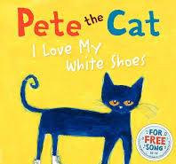 | Drawing Club  We will be drawing The Little Red Hen and a cunning fox in Drawing Club.  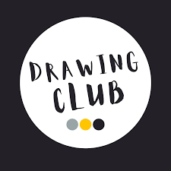
Curious Conversations:
What is your favourite colour?

My favourite colour is…..because…
…

Pete The Cat Link https://www.youtube.com/watch? v=fj_z6zGQVyM&t=16s

Phonics  .  We will be learning to write the spellings for the sounds:  g o c k  We will be learning to spell the tricky word to and the and the high frequency words on, can, dad got not  Please see Home Learning Phonics for further details | Our value this week is -  Good Manners  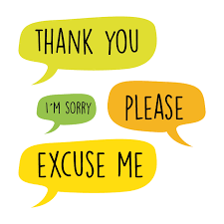  To treat others with courtesy and politeness and behave well towards them  The children will demonstrate in a variety of ways different levels of good manners throughout their learning this week including .  Our behaviour expectation this week is: Do be polite. Do be gentle |  | Shadows  We will explore shadows  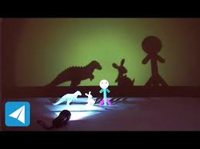

To answer the questions of the week How many colours can you see around you?, we will be going on a colour hunt to find out how many colours are in our environment.  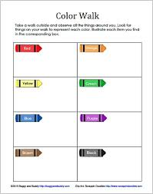 | We will be learning how to use water colour and mark make.  We will be using a water colour palette and a thin brush  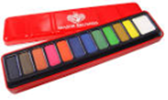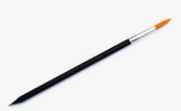  We will be reinforcing the range of marks we learnt when sketching and drawing - circle, dot, cross hatch, horizontal line, vertical line.  Creating marks with watercolours:  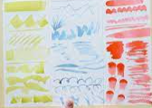 | We will be finding out about how the artists Vincent Van Gough Paul Klee used water colour and mark making.  Vincent Van Gogh - Wheat Stacks in Provence  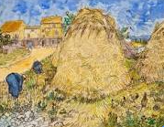  Paul Klee - Light and Sharpness  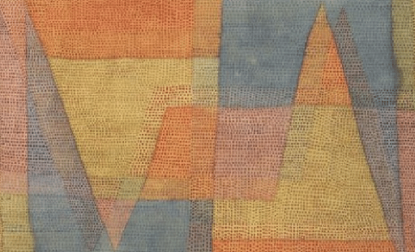
Finger Numbers.  We will be playing a game where we listen for a number and show the amount of fingers. We will then try and show the number on two hands.  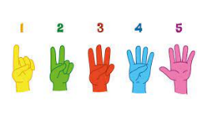 | We will ordering lengths – first of all using pencils and crayons. We will be using the words – lonest shortest, order.  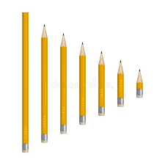  And then we will find other things to order. What can you find at home to order. | Please share Library Book Club  

