Question of the Week: How many creatures find their homes in the Foundation Stage garden? WB: 5.5.25
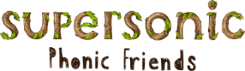  In Phonics we will be revisiting the Basic 3 spellings for the sounds and learning cvcc words.  Tricky Words  house, when, our, your | In Handwriting, we will be continuing to practise writing our Len’s Ladder 2 letters.  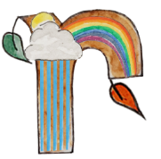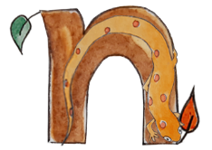  We will be recognising which letter family the letters come from and saying the ditties as we practice! |   In Writing, we will be writing sentences that include the spellings for the sounds, high frequency words and tricky words that we are learning and revising.  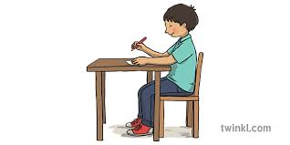 | Maths  In Maths the children will be continuing their learning of weight. They will be measuring a variety of different objects and be encouraged to use the vocabulary heavy/light/heavier/lighter/holds more than.  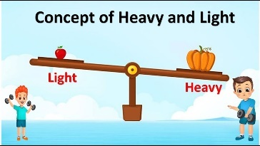
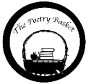  Under a Stone  Under a stone where the earth was firm,  I found a wiggly, wriggly worm.  “Good morning,” I said.  “How are you today?”  But the wiggly worm just wriggled away.  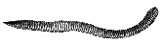 | Our topic is ‘Nature Detectives’ – Mini Beasts  We will be reading –  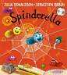  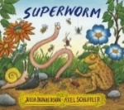  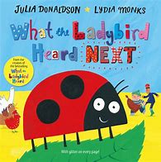  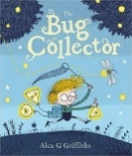  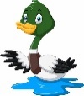  We will be looking at nature in the environment. In particular, wild life on the canal and mini beasts in the garden. We will visit our bug hotel. |  | Parents Hints and Tips  Coats & Sunhats  Please ensure children have a waterproof coat and a sunhat everyday. We are outside regardless of the weather.  Please apply suncream before your child comes to school. Thank you.

