English  This week we will be reading The Lion Inside and focus on writing in sentences using a capital letter and full stop. | Maths  We will be recognising the addition symbol and adding numbers together below 10. Understanding number sentences. | PE  Our focus in PE in this half term will be multi-skills Please ensure your child has a full, named PE kit including joggers as we will sometimes be outside.
Music  We are learning songs and moving our body to the pulse. | Week beginning 13.10.25  Incredible Me!  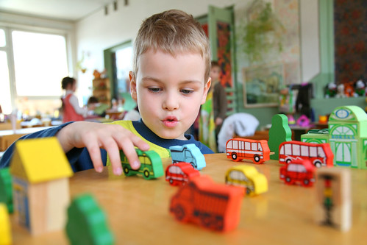 | Science  Animals and Humans  We will be observing, investigating and comparing the human body. We will be working on our questioning skills, identifying what makes a good question.
Poetry  We will be looking at classic Poems from our “Poetry Basket”.  This half term our poems are “All About Me” |  | Art  This half term we are going to be looking at sketching and mark making in Art and using H and B pencils to create different effects.
 | PSHE  This half term we are focusing on looking at our school values and what they mean. This week we are going to be looking at reflect. | Geography  This week we will be using observational skills to study the geography of Wendover and the landmarks around.
Phonics
We will be recapping and reviewing Basics 4 and reading CVCC words and B4 tricky words.

