English  This week we will be completing indepdent writing in our provision. | Maths  We will be looking at completing subtraction number sentences within 20 independently. | PE  Our focus in PE in this half term will be multi-skills Please ensure your child has a full, named PE kit including joggers as we will sometimes be outside.
Music  We will be exploring musical sounds and how they can be changed focussing on timbre, dynamics and pitch. | Week beginning 9.2.26  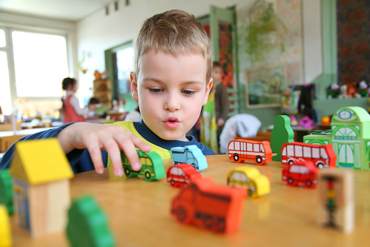 | Science  This week we will be assessing the right materials
Poetry  We will be looking at classic Poems from our “Poetry Basket”.  This half term our poems are “Space” |  | Art  This half term we will be working on mixing of primary colours.
 | PSHE  This half term we are focusing on looking at feelings and how to regulate your own feelings. | DT  This week we will be designing and making our own toys, using the joins we have learnt. We can then evaluate our make.
Phonics
We will be working through the choose to use sounds and tricky words.

