Daily sessions include
- Art and crafts or cooking
- Roleplay area
- Snack time
- Games
- Construction
- Outdoor play
- Small world
Our Aims
- To develop independence
- To provide a loving caring environment
- To provide security
- To promote a sense of belonging


Manager Deputy Manager
Welcome to OOSC
We aim to provide a setting where your child feels safe, secure and relaxed, where they can challenge themselves through play and enjoy building new friendships. We value good relationships with the whole family and are committed to working in partnership to provide the best care possible for your child.
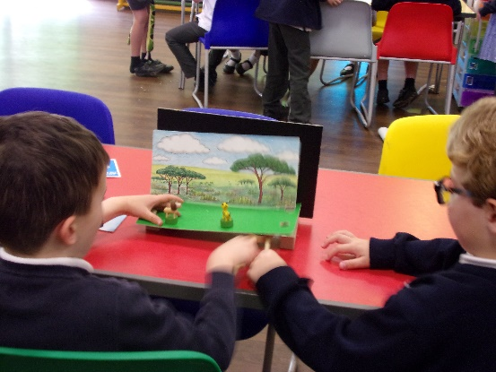
John Hampden Out of School Care

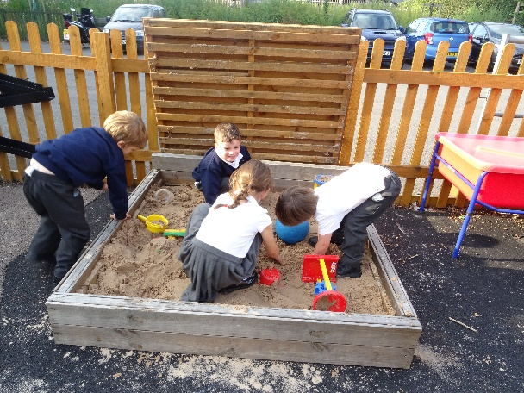
For more information contact:
Sharon Cottle – OOSC Manager
The John Hampden School Wendover
Wharf Road
Wendover
HP22 6HF
Tel: 07506195699
Or email oosc@jhampden.bucks.sch.uk

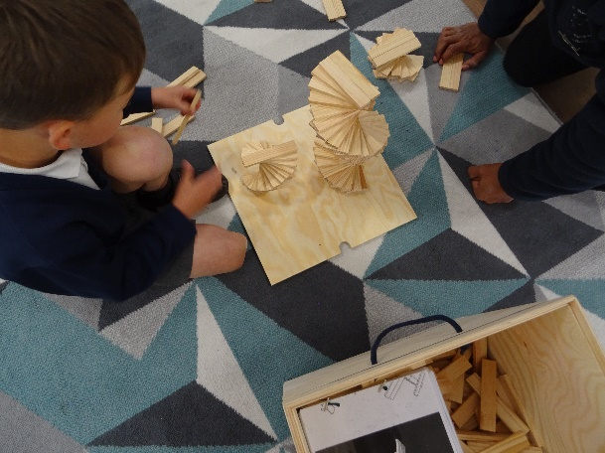
Provide a sense of belonging
- Making all family members feel welcome
- Following school values and golden rules
- A shared transition policy with EYFS
- Listening to ideas, opinions and feelings of all the children attending
- Encouraging responsibility for others as well as ourselves
- Excellent communication with parents
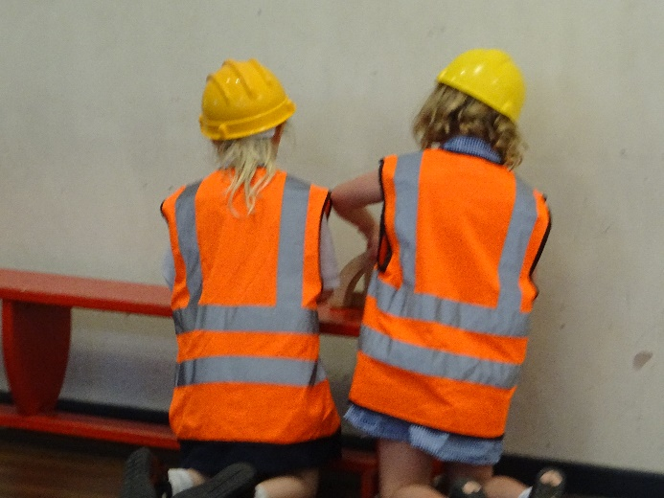
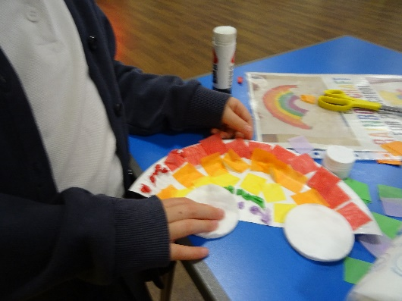
Providing security
- Risk assessments, equipment checks & password system
- Excellent staff/pupil ratios
- Ensuring the children are aware of any changes and introducing visitors or new staff members
- Working in partnership with school staff to ensure smooth transitions
A loving and caring environment
- Providing a key person for your child, helping them to settle quickly
- Supporting children with social interactions using buddy and playmate systems
- Working in partnership with parents and getting to know the whole family
Parent Comments
“The OOSC is thoughtfully planned with the children in mind.”
“Fantastic variety & quality of activities. The caring, enthusiasm and quality of staff is amazing.”
“A wide range of activities available daily. The children feel secure, safe and loved.”


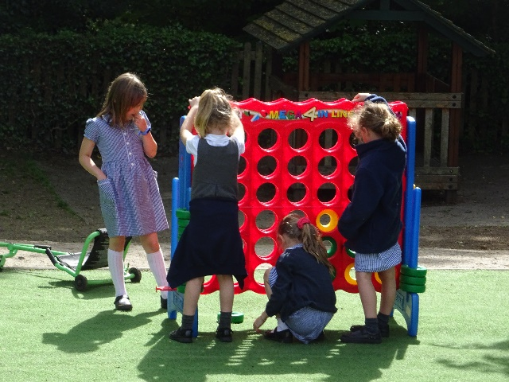
Developing independence
- Encourage perseverance.
- A Buddy scheme-supports children to become familiar with the routines.
- Promoting life skills-tidying up & helping with snack.
- Circle time- enables the children’s choices, ideas and opinions to be shared.

