PE  Multi-Skills    Playground Equipment Games  Focus: Idependent play  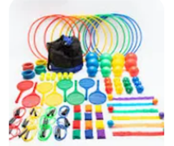 | ENGLISH  Last Stop on Market Street  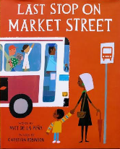  This week we will starting our new narrative which explores a journey story.  HANDWRITING  Practising the letter formation families and 17 seventeen.  PHONICS  Daily Choose to Use Phonics Sessions  READING  Daily Story Sessions & Learn a Poem.  Remember to bring in reading books and diaries every day. Please sign the diary when you have heard your children read. | 2.11.26  Our question of the week is:  How can I keep myself safe?  Our value this week is:  Belonging  Our Behaviour Focus this week is:  Do Look After Property  Poem we are Learning:  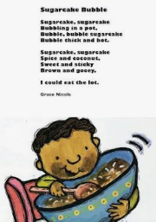  ‘Sugarcake Bubble’ by Grace Nichols | MATHS  Number  Representing Numbers and Counting in 2s, 5s and 10s  How many 2 digit numbers can you make with these digit cards?  Now order them from smallest to largest.  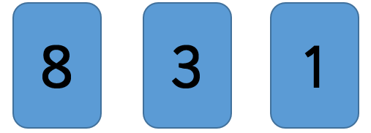
ART  Sketching and Mark Making  We will be using all our new mark making techniques to sketch our own choice of subject.  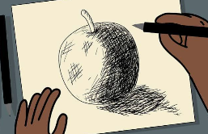 |    | MUSIC    To identify beats in a bar  To compose 4-beat sound patterns    To create a simple graphic score |   Your first task is to decorate your homework books.    Please see the success criteria inside your homework book.
 | MUSIC  We will be learning the songs for our Christmas Nativity.  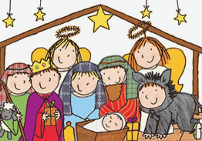 | COMPUTING  Building on their block coding from Autumn 1, this half term we will be learning to code using Scratch.  

