We will be looking at information books about people who help keep us safe and discussing who can help us if we get lost.  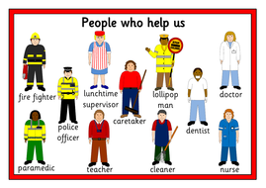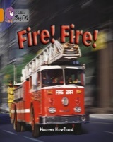 | We will be reading stories about keeping ourselves safe.  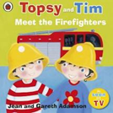  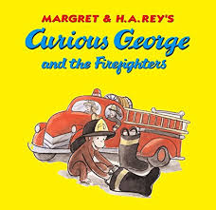  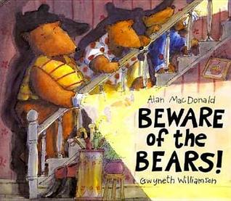 | We will be learning about how to keep ourselves safe online.  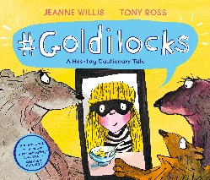
We will be learning about how to keep ourselves safe around fire, especially on Bonfire Night.   | We will be learning about road safety and meeting the local Road Traffic Safety Officer as well as having the local Police Officers in.  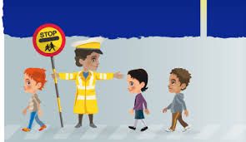 | We will be learning about Stranger Danger and what to do if we get lost.  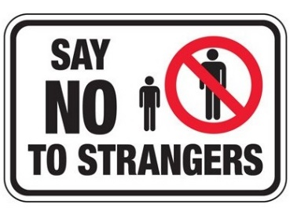
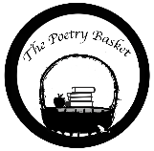  A Pointy Hat  A little old lady, with a tall pointy hat,  Knocked on the door with a rat-a-tat-tat.  I looked through the window to see who was there, but off she went flying through the air. | We will be doing an observational drawing of a toy fire engine, reflecting on it and then seeing if we can make it even better!  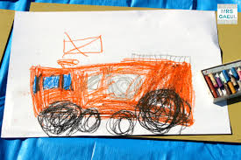 | We are continuing to learn our phase 2 sounds and these are some games you could play with your child:  Phonics Play  https://www.phonicsplay.co.uk/resources/phase/2/pick-a-picture  https://www.phonicsplay.co.uk/resources/phase/2/buried-treasure  https://www.phonicsplay.co.uk/resources/phase/2/dragons-den  https://www.phonicsbloom.com/uk/game/flash-cards?phase=2

