WB: 29.1.24
Question of the Week – What do you think is beyond the sky?
We are learning the spellings for the sounds ai, ee, igh and oa. We will beginning to use these in our writing.  We will also be focusing on our Tricky Tess words and our high frequency words. We will be developing our reading memory to help us read with speed | In handwriting, we will be continuing to practise forming the letters we have been learning. Our focus will be l, i, t, u and y from Len’s Long Ladders.  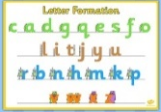 | We are writing for a range of purposes. The adults are reminding us to write a label for a model or instructions of how to make it.  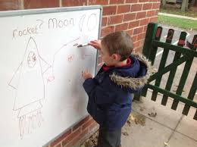  In handwriting, we will be continuing to practise forming our letters using the supersonic phonic letter families and ditty’s |  | Maths  This week we will be comparing quantities and saying whether they are equal, unequal or the same.  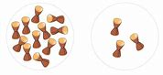  Which set has the fewest?
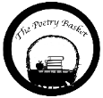  Climb Aboard the Spaceship!  Climb aboard the spaceship,  We're going to the moon.  Hurry and get ready,  We're going to blast off soon.  Put on your helmet,  And buckle up real tight.  Here comes the countdown,  Let's count with all our might.  10-9-8-7-6-5-4-3-2-1 Blast-off! | Our topic is  Explorer, Explorer  What do you think is beyond the sky?  We will be reading lots of different space stories and looking at non-fiction books about space travel, the moon and planets  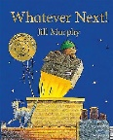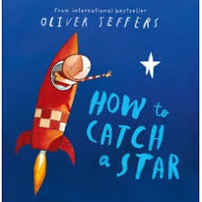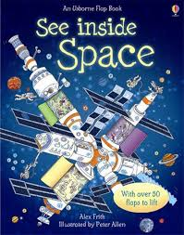 |  | Topic  We are thinking about Space Travel and will be making our own rockets using a variety of  different materials and mediums.  We will also be finding out about famous astronauts Neil Armstrong, Mae Carol Jemison and Tim Peake | Parents Tips and reminders  Read! Read! Read!  Children will be allocated a specific day each week when they will change their reading books. Please continue to read at home every evening and sign to say you have heard your child read.  Please remember to send children in with a warm coat, hat, gloves and scarf everyday.  We will go outside whatever the weather!

