9.11.26 | Value: Belonging | Behaviour Expectation: Do look after property

We will be pulling up the vegetables we planted and making vegetable soup.  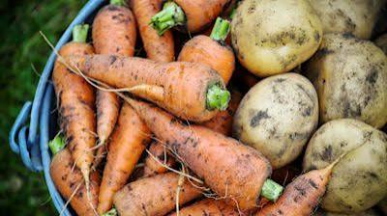 |   Poetry Basket Poem  Sliced Bread  Slice, slice the bread looks nice,  Spread, spread, butter on the bread,  On the top put jam so sweet,  Now it’s good enough to eat | Please share Library Book Club book  
We will be learning about water safety   | We will be doing observational drawings of different fruit  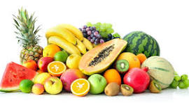
We will be learning about Remembrance Sunday   | Phonics  We will continue to hear syllables in words.  We will be learning to write the spellings for the sounds:  i n m d  We will be learning to write the tricky word as and the high frequency words  it, in, am, dad  Please see Phonics sheet for further details

