Question Of The Week: How are colours and lights used in celebrations? WB: 04.12.23
We will be learning about  colour and light in celebrations and reading the story  ‘Little Glow’ which introduces children to different cultural festivals including  Diwali, Hannukah, Ramadam, Chinese New Year and Christmas  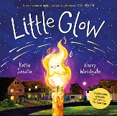 |  | We will be continuing to explore and investigate how light travels through or reflects off of different materials including christmas baubles, tinsels, bells and beads  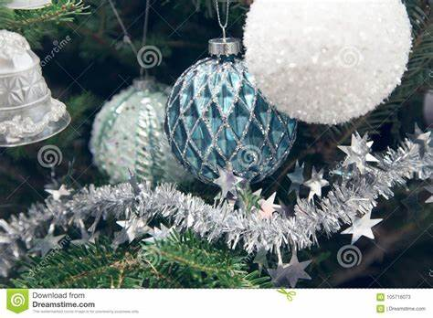 |  | Handwriting  We will be practicing writing the correct letter formation for f,  and practicing writing Tricky Tess words, CVC words and short captions and sentences  eg. I, to, no, go, the, into  I am, I can, It is a…..
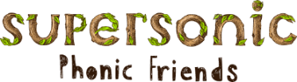  In Supersonic Phonics we will be learning the spellings for the sounds f, ll, ff, ss.  We will continue to learn ‘Tricky Tess’ words of, into  and practicing I, is, a, A, to, the , The, no, oh ,to, has, his, as. |  | In Maths  Children will be continuing with positional language, challenge your child and ask them to place their favourite toy on top, underneath, next to, behind, in front of different objects.  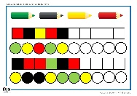  Children are also continuing to learn about patterns both  in numbers, objects and colours. These patterns may consist of two  and three variables.
We will be reading the story of  ‘The Nativity’ and discussing the meaning of Christmas.  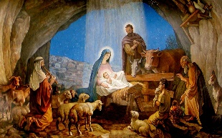  We will be learning that the bible is a special  book used by Christians. | ** Christmas Nativity play**  Wriggly Nativity  Wednesday 6th & Thursday 7th December  9.30am – Tickets only  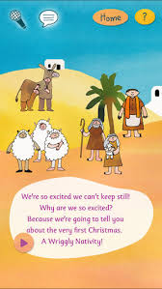 |  | Parents Tips and Reminders  Please ensure children bring their Reading Packs every day. These will then be changed on a Friday.  Please listen to your child read every night and sign to say you have heard them read.  The weather is now getting colder. Please send your child in with appropriate outdoor clothing

