PE  Athletics  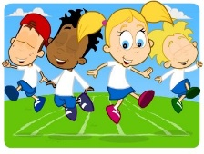  Mindful minutes | ENGLISH  Narrative: Superhero Stories    The children will continue to listen to Superhero Stories. They will plan and write their superhero stories.  SPAG / HFW / TW / CEW. Reading comprehension / Guided Reading - Fiction / Non-Fiction  HANDWRITING  Introduction to horizontal joins  PHONICS  Daily Phonics Sessions.  READING  Daily Story Sessions & Learn a Poem.  Remember to bring in reading books and diaries every day. Please sign the diary when you have heard your child/ren read. | 13.7.26  We will continue to focus on our school Behaviour Expectations & Values.  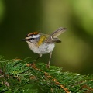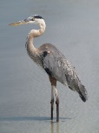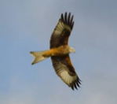  We will be reading:  Superhero stories, Non-fiction & Poems  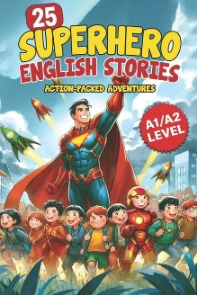  SPELLINGS  Please help the children to practise their High Frequency and Common Exception Words | MATHS  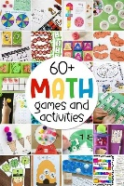  A selection of our favourite maths activities.  If you have time at home could you please try to measure mass perhaps when you are cooking or baking. | MUSIC  Practising our performance songs!  
COMPUTING  Safe Searching, Photography and Pictograms in Computing Lessons.  Leavers Practise  Classes to practise ready for the Leavers Assembly. |  |  | SCIENCE  The children will be looking at food chains including predator and prey.  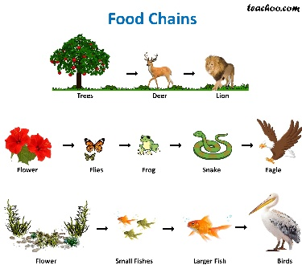  .  TRANSITION DAY  The children will visit their new teachers on Wednesday.
  Behaviour Expectations & Values  Reflection  Circle Time  Focus on change. |  | Homework    New homework was issued on 2.7.26 and needs to be returned on 14.7.26. The children’s homework is to write a letter to their new teacher. Please see the example letter included and complete on the paper provided, neatly and in pencil. | FINE & GROSS MOTOR  Further developing of cutting skills.  A range of fine & gross motor skills.  